**ASSIGNMENT-1**

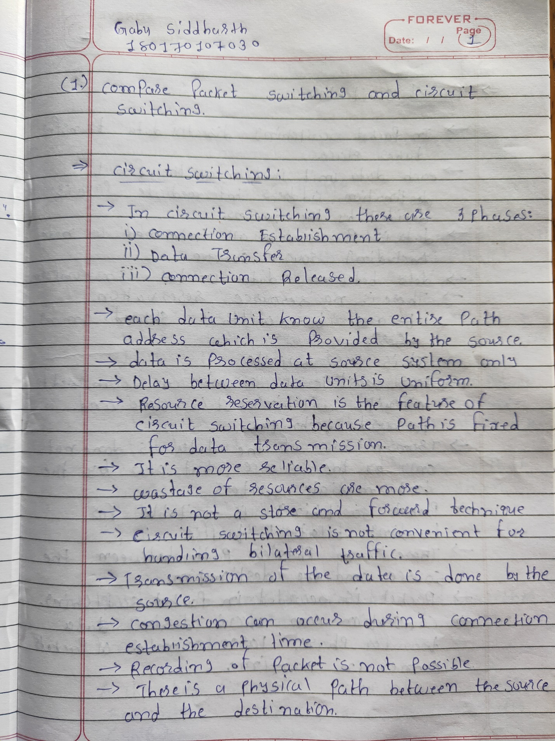

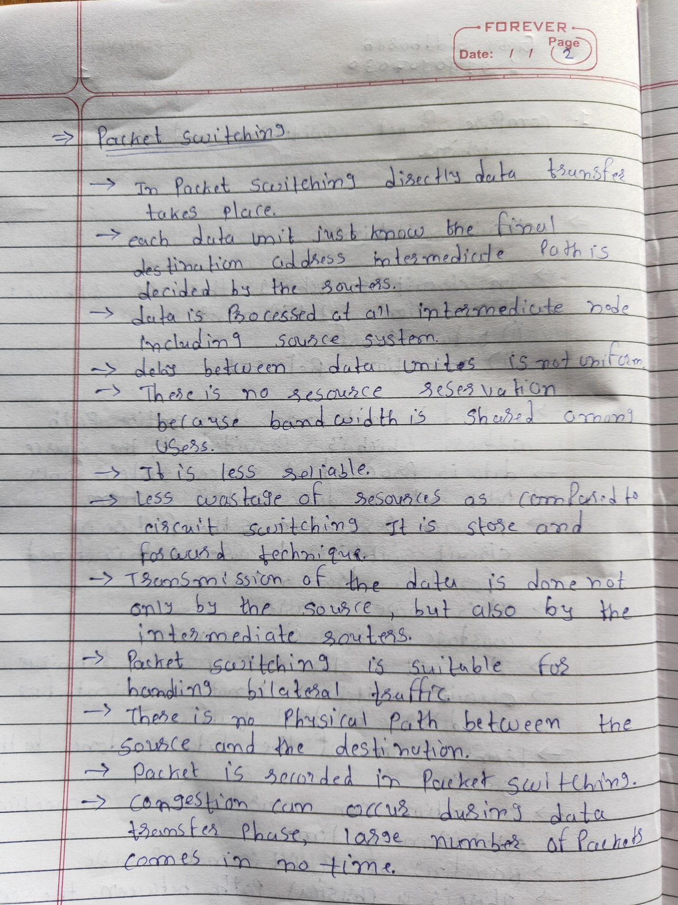

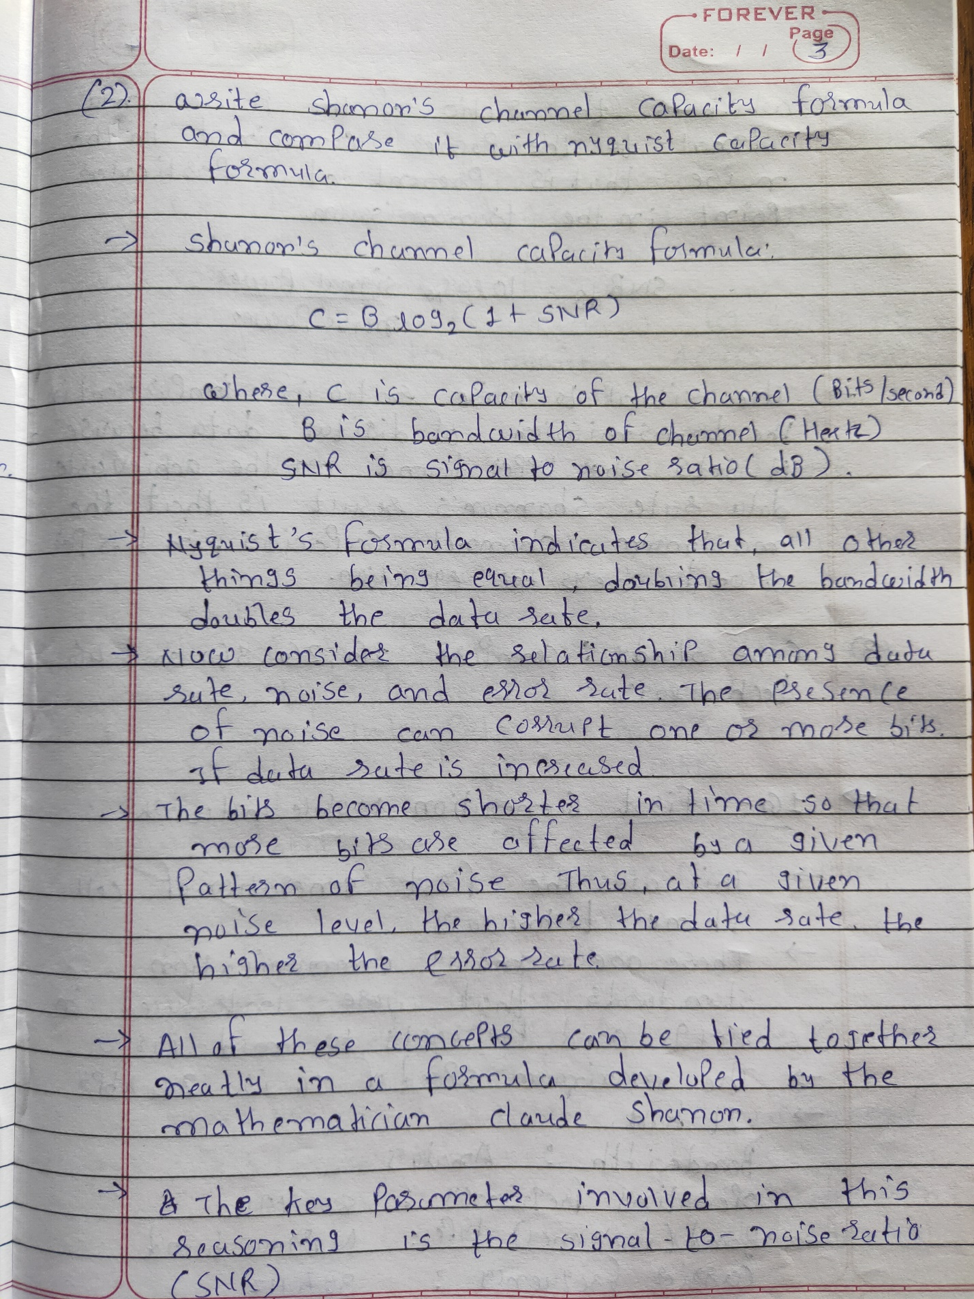

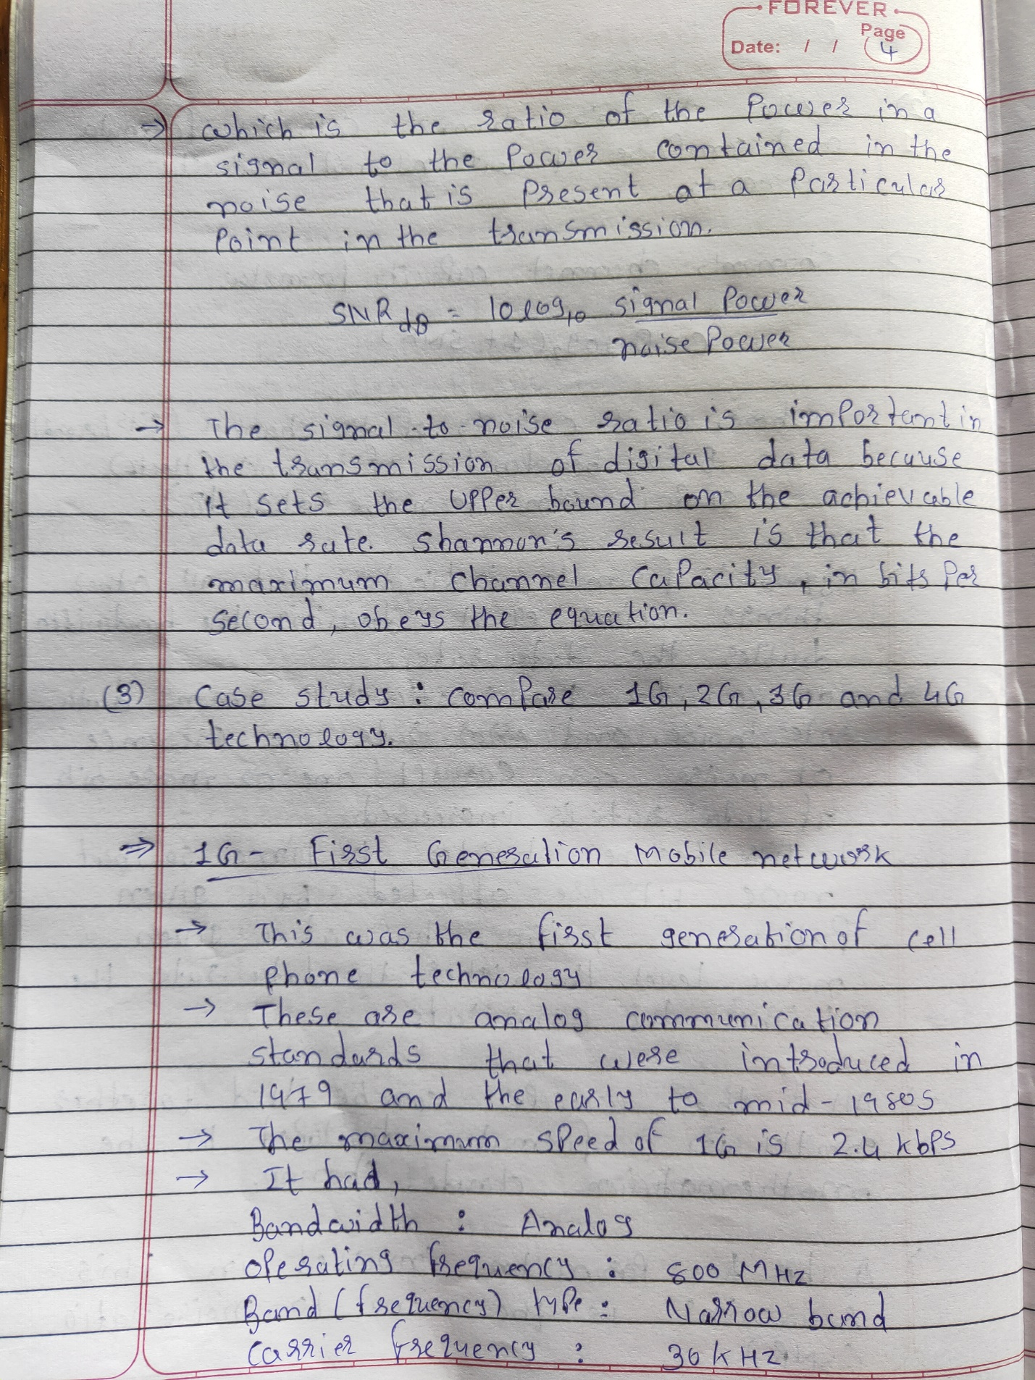

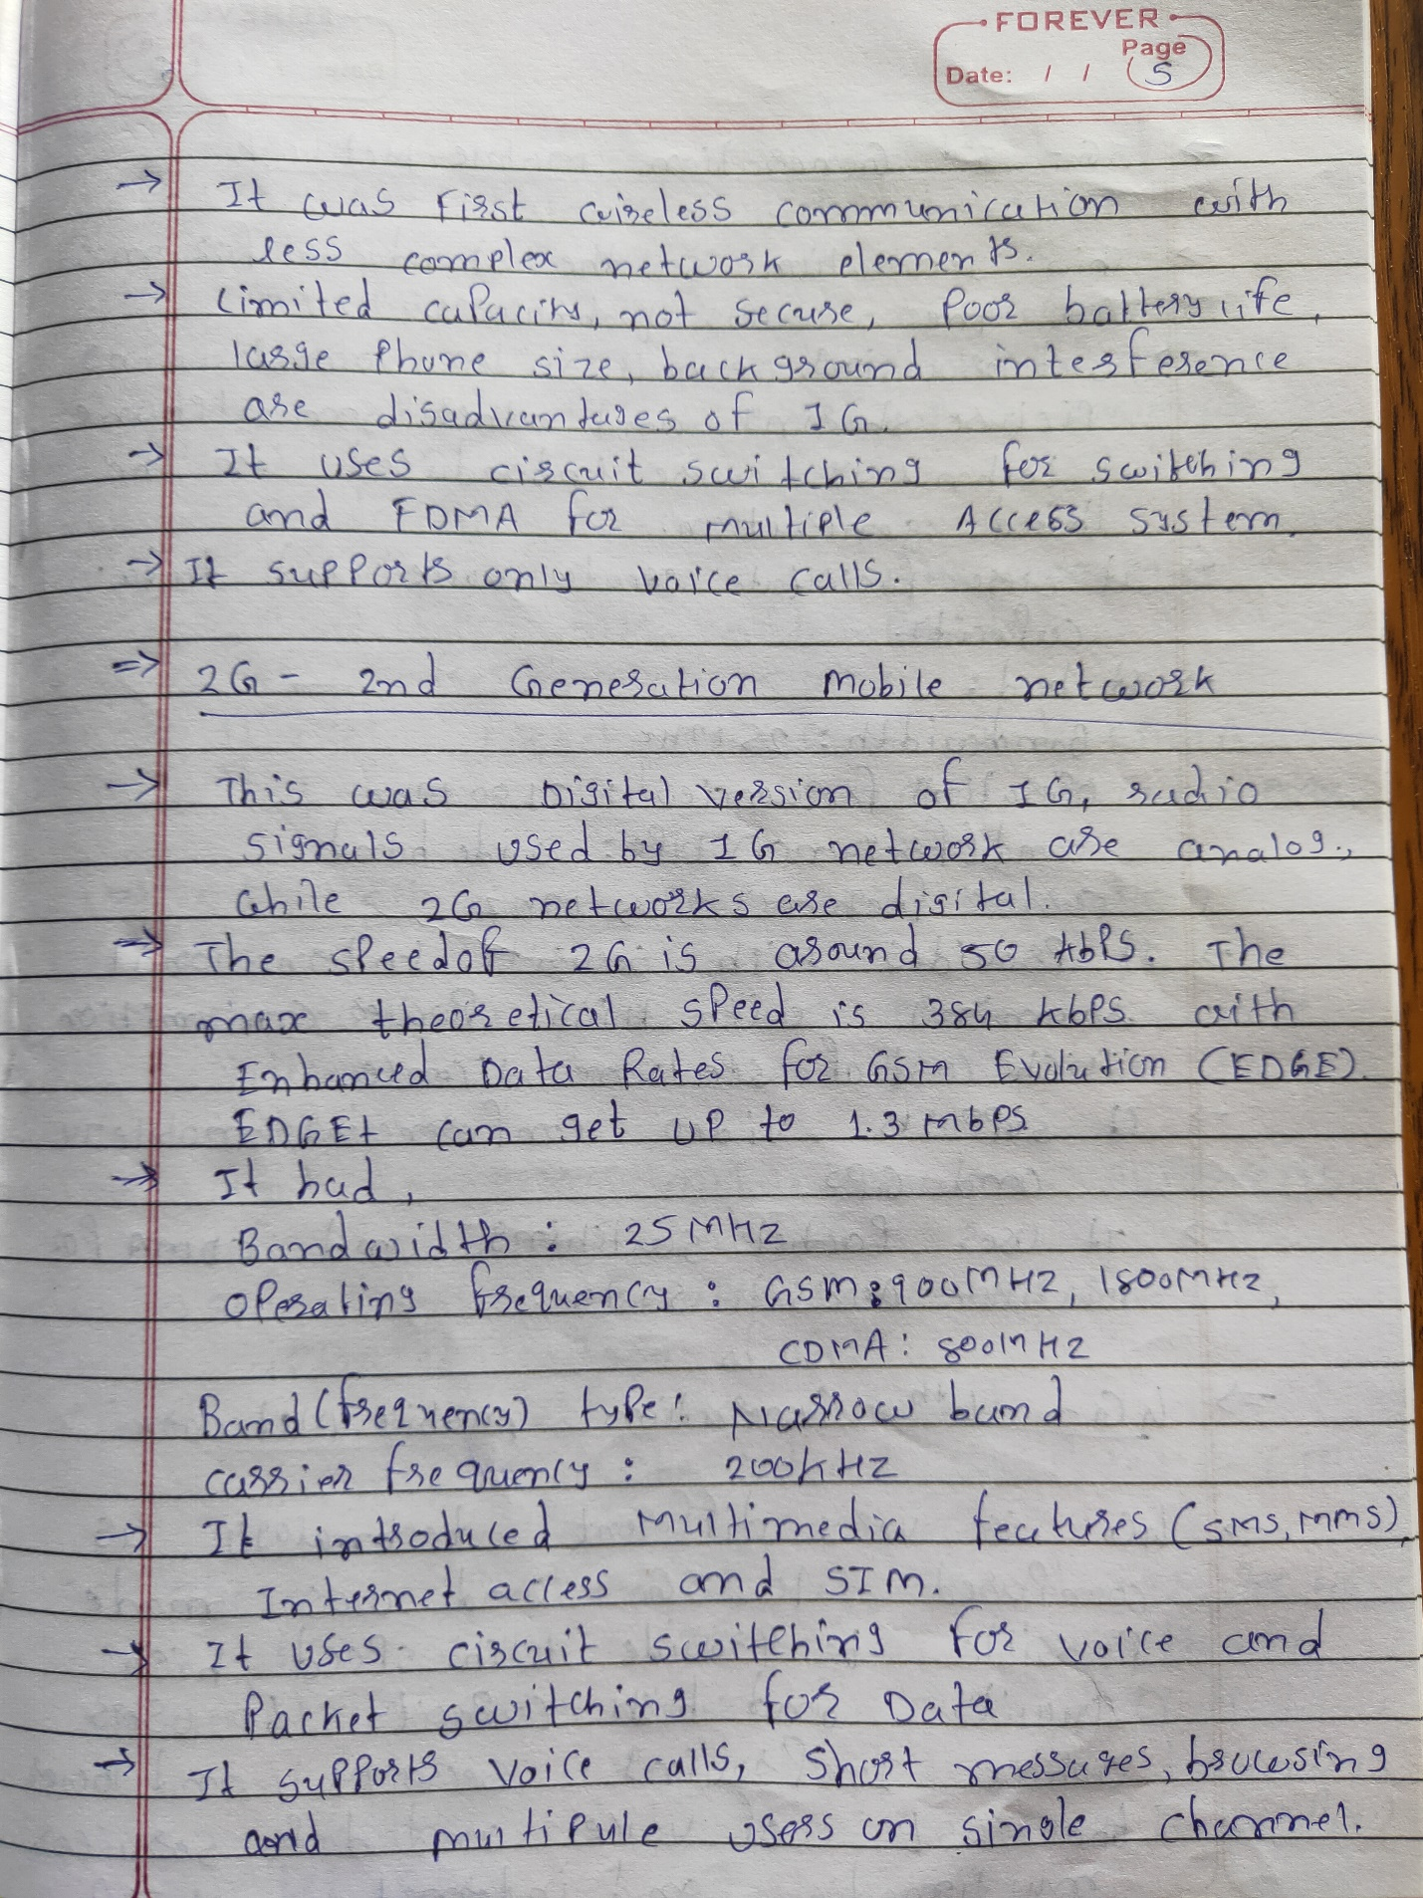

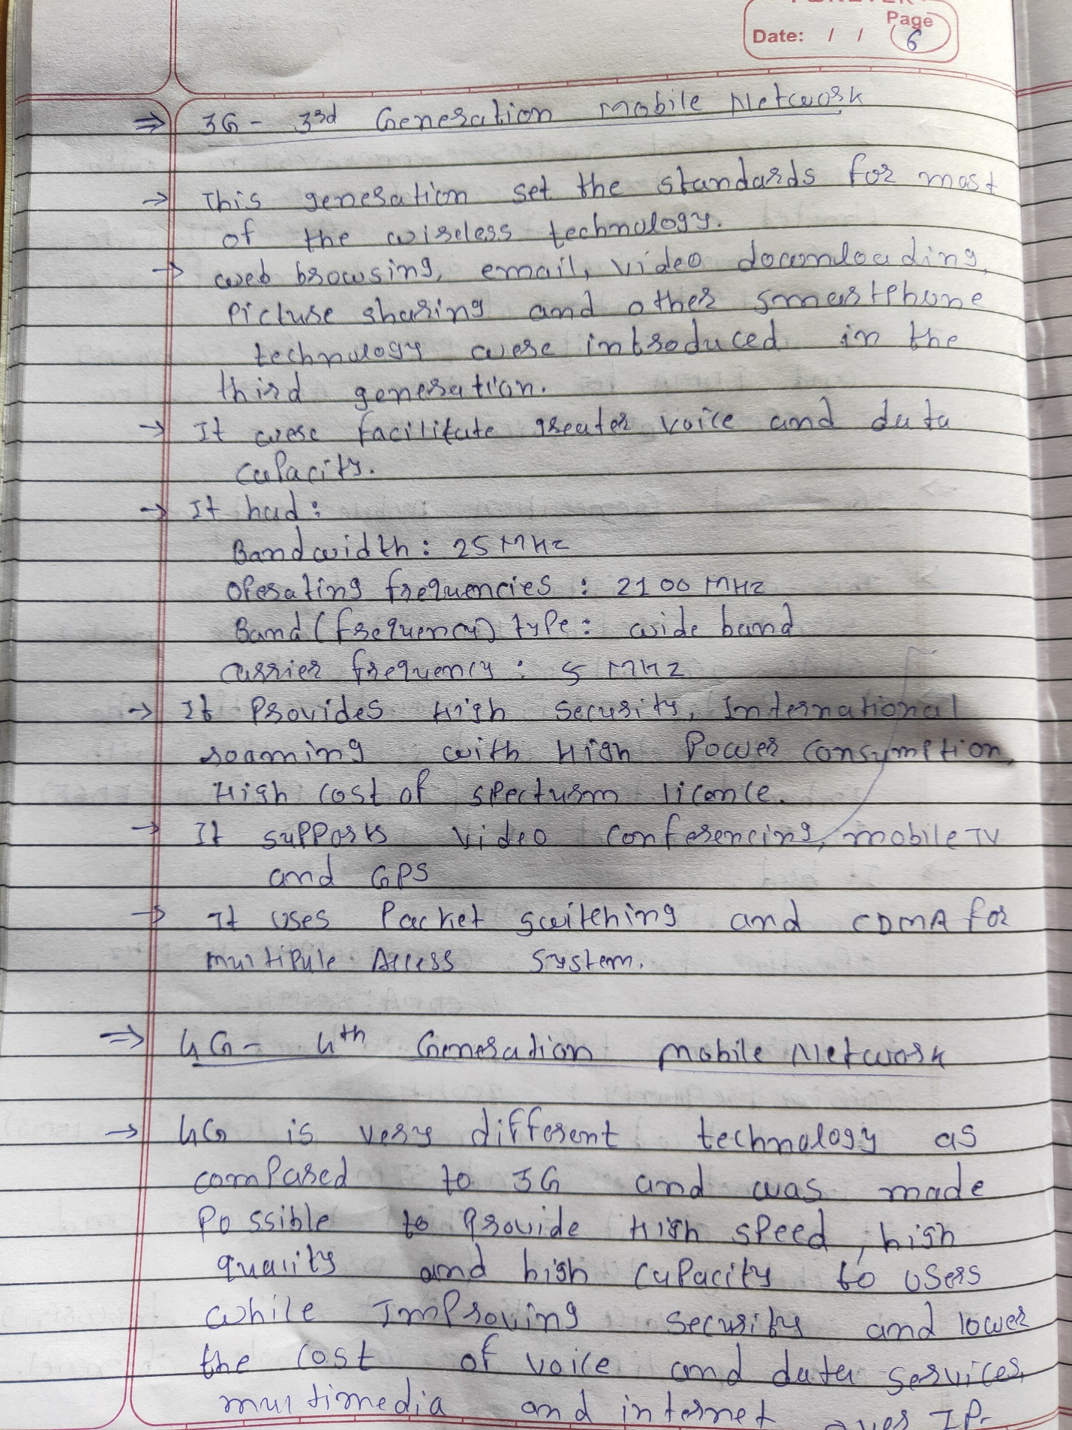

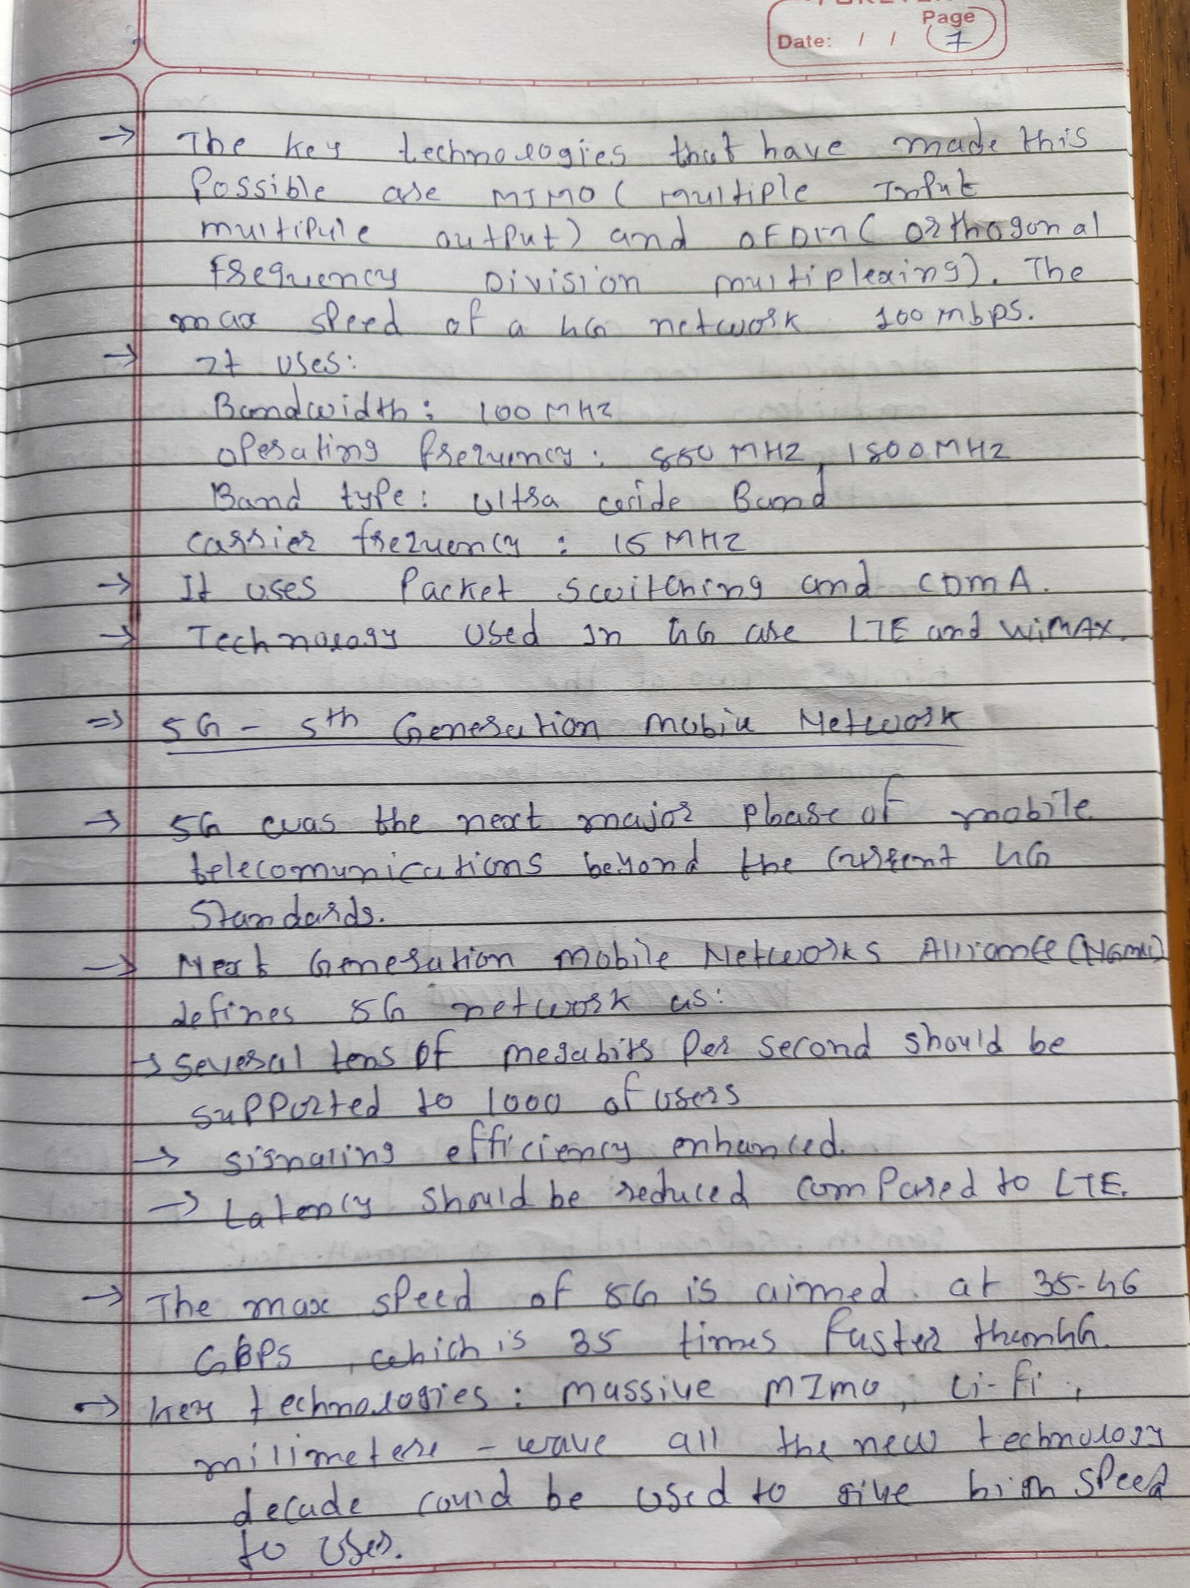

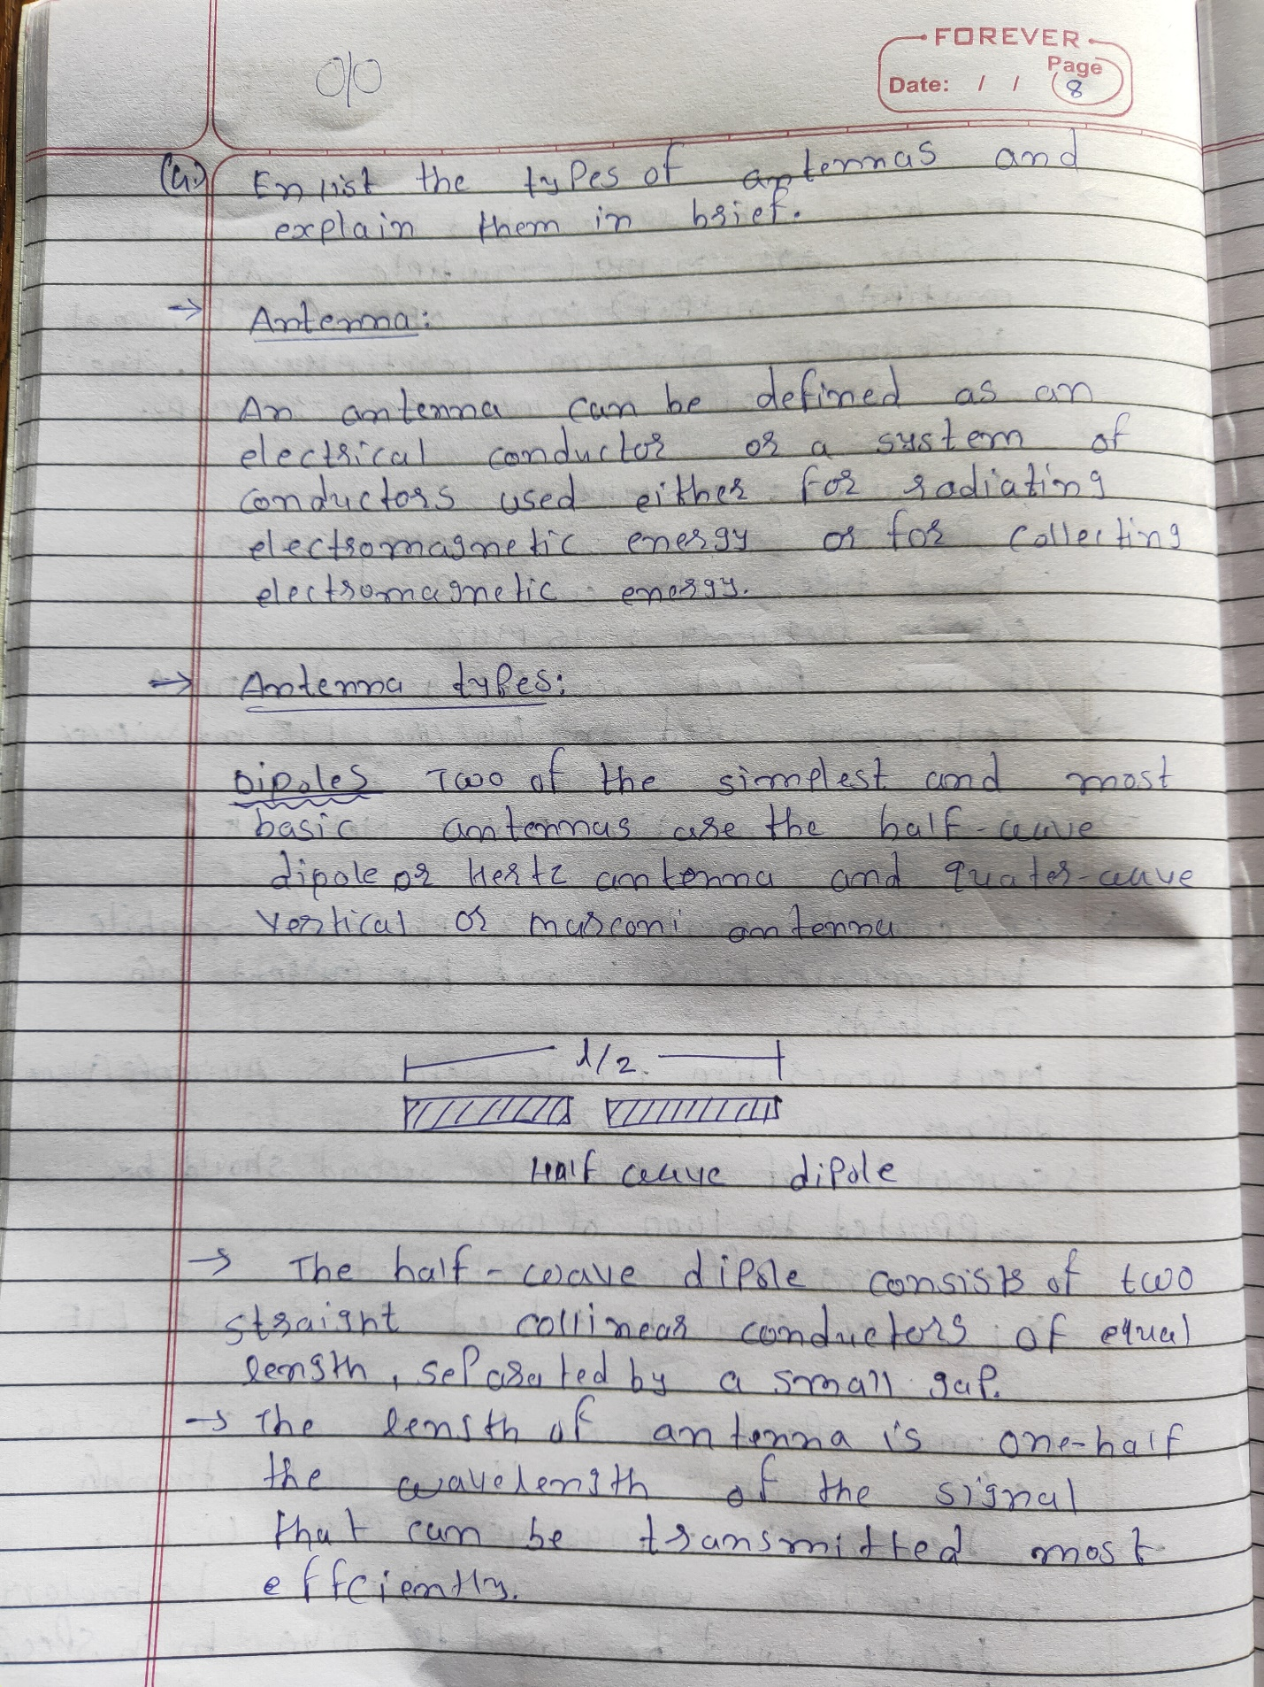

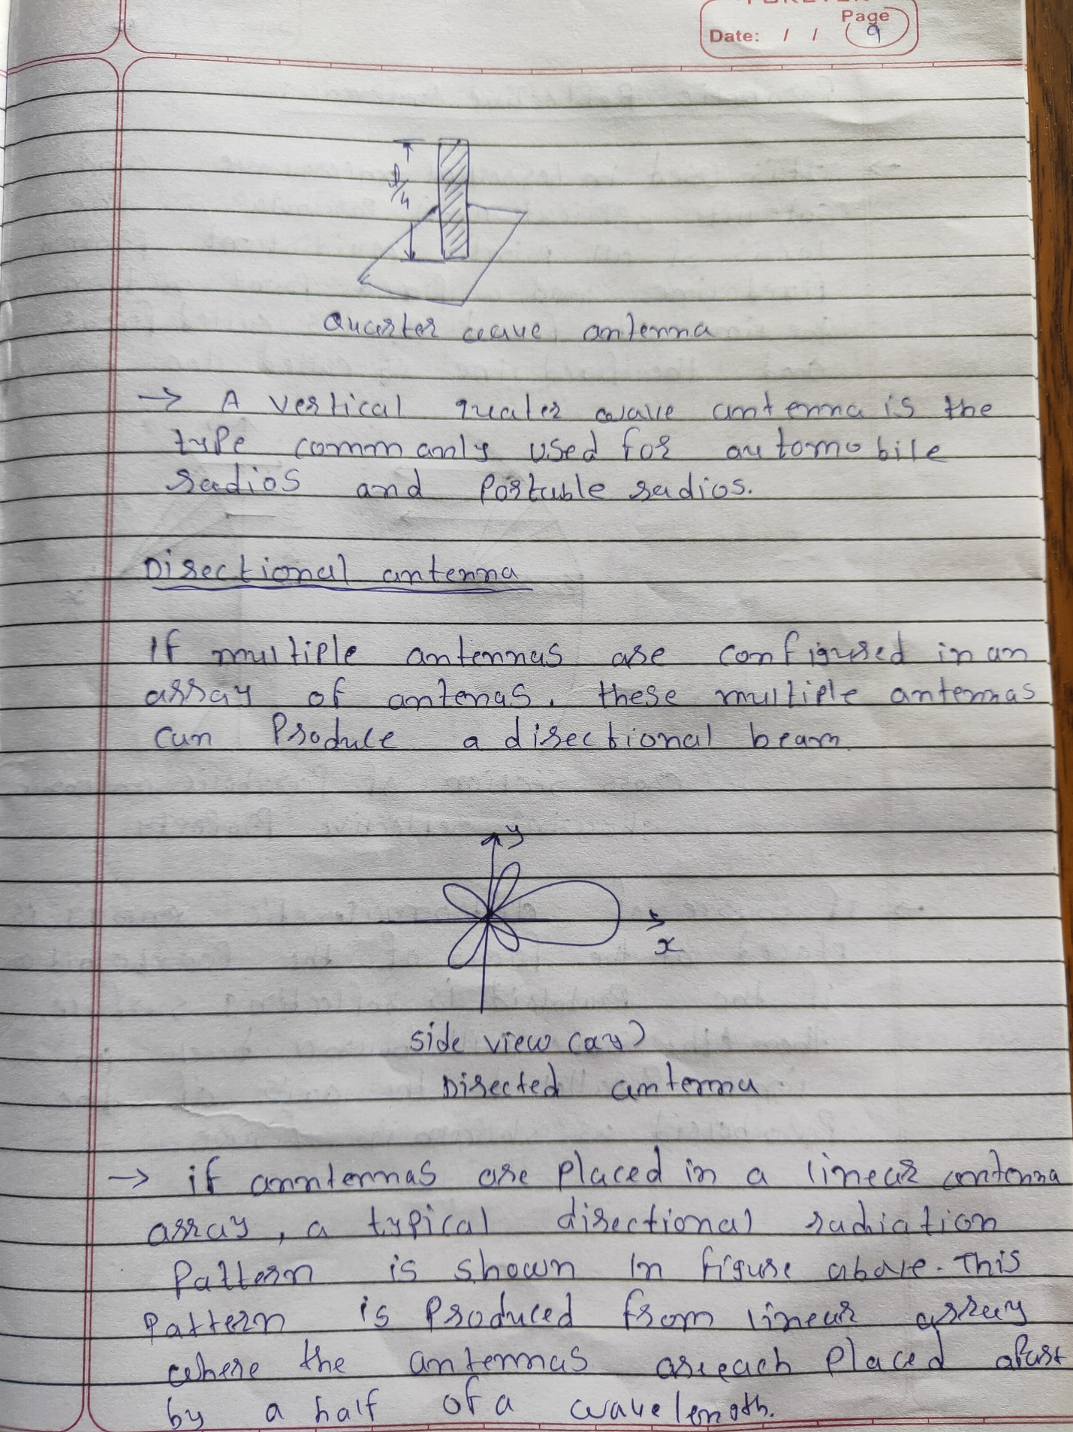

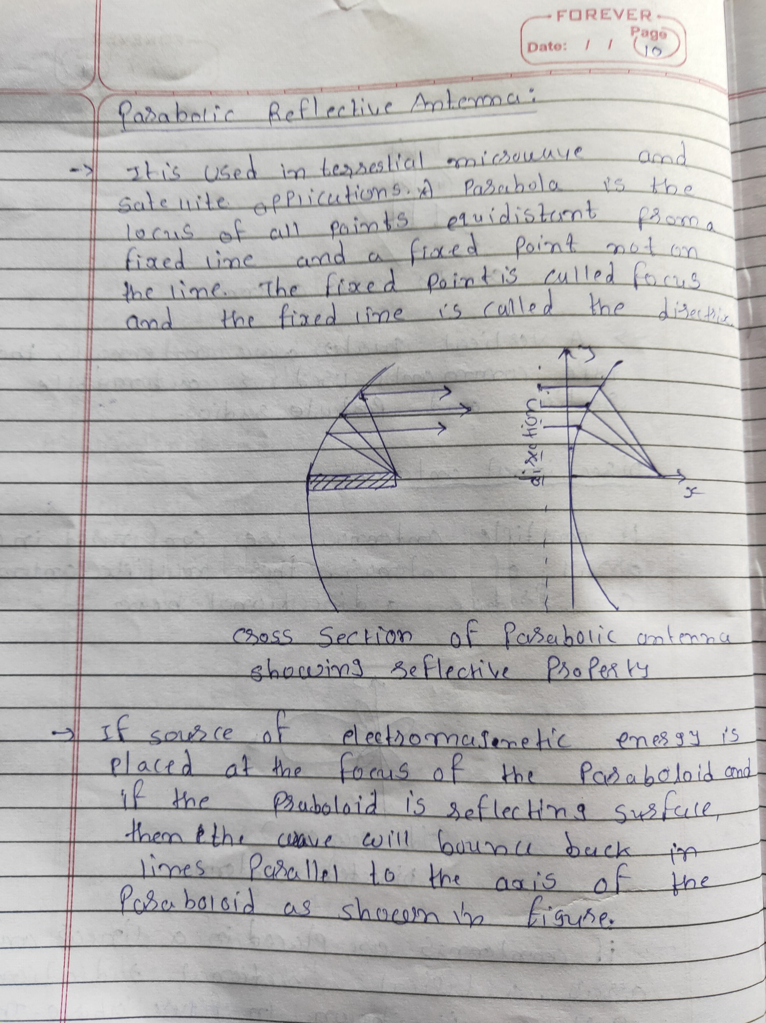

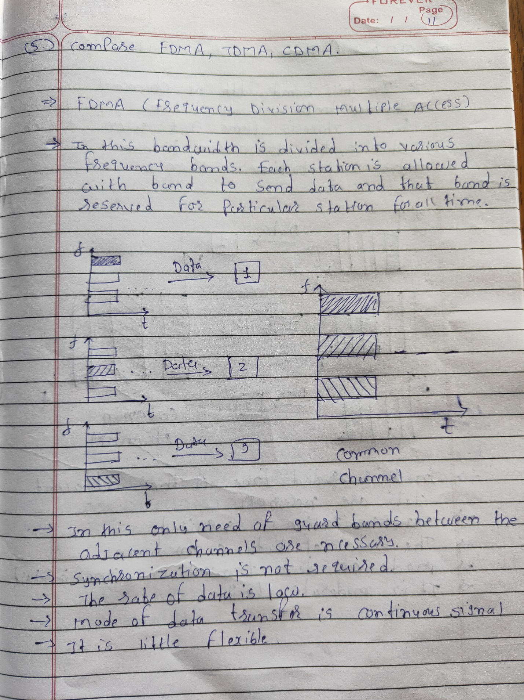

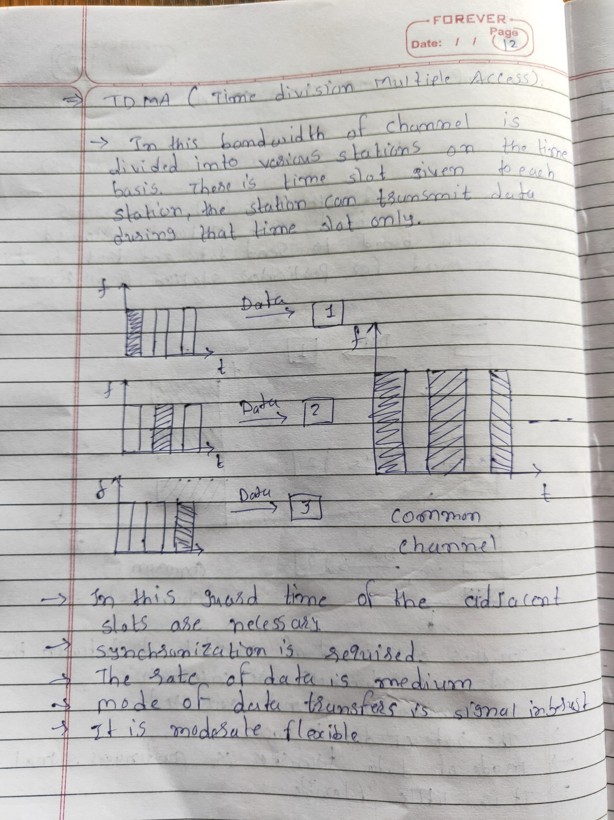

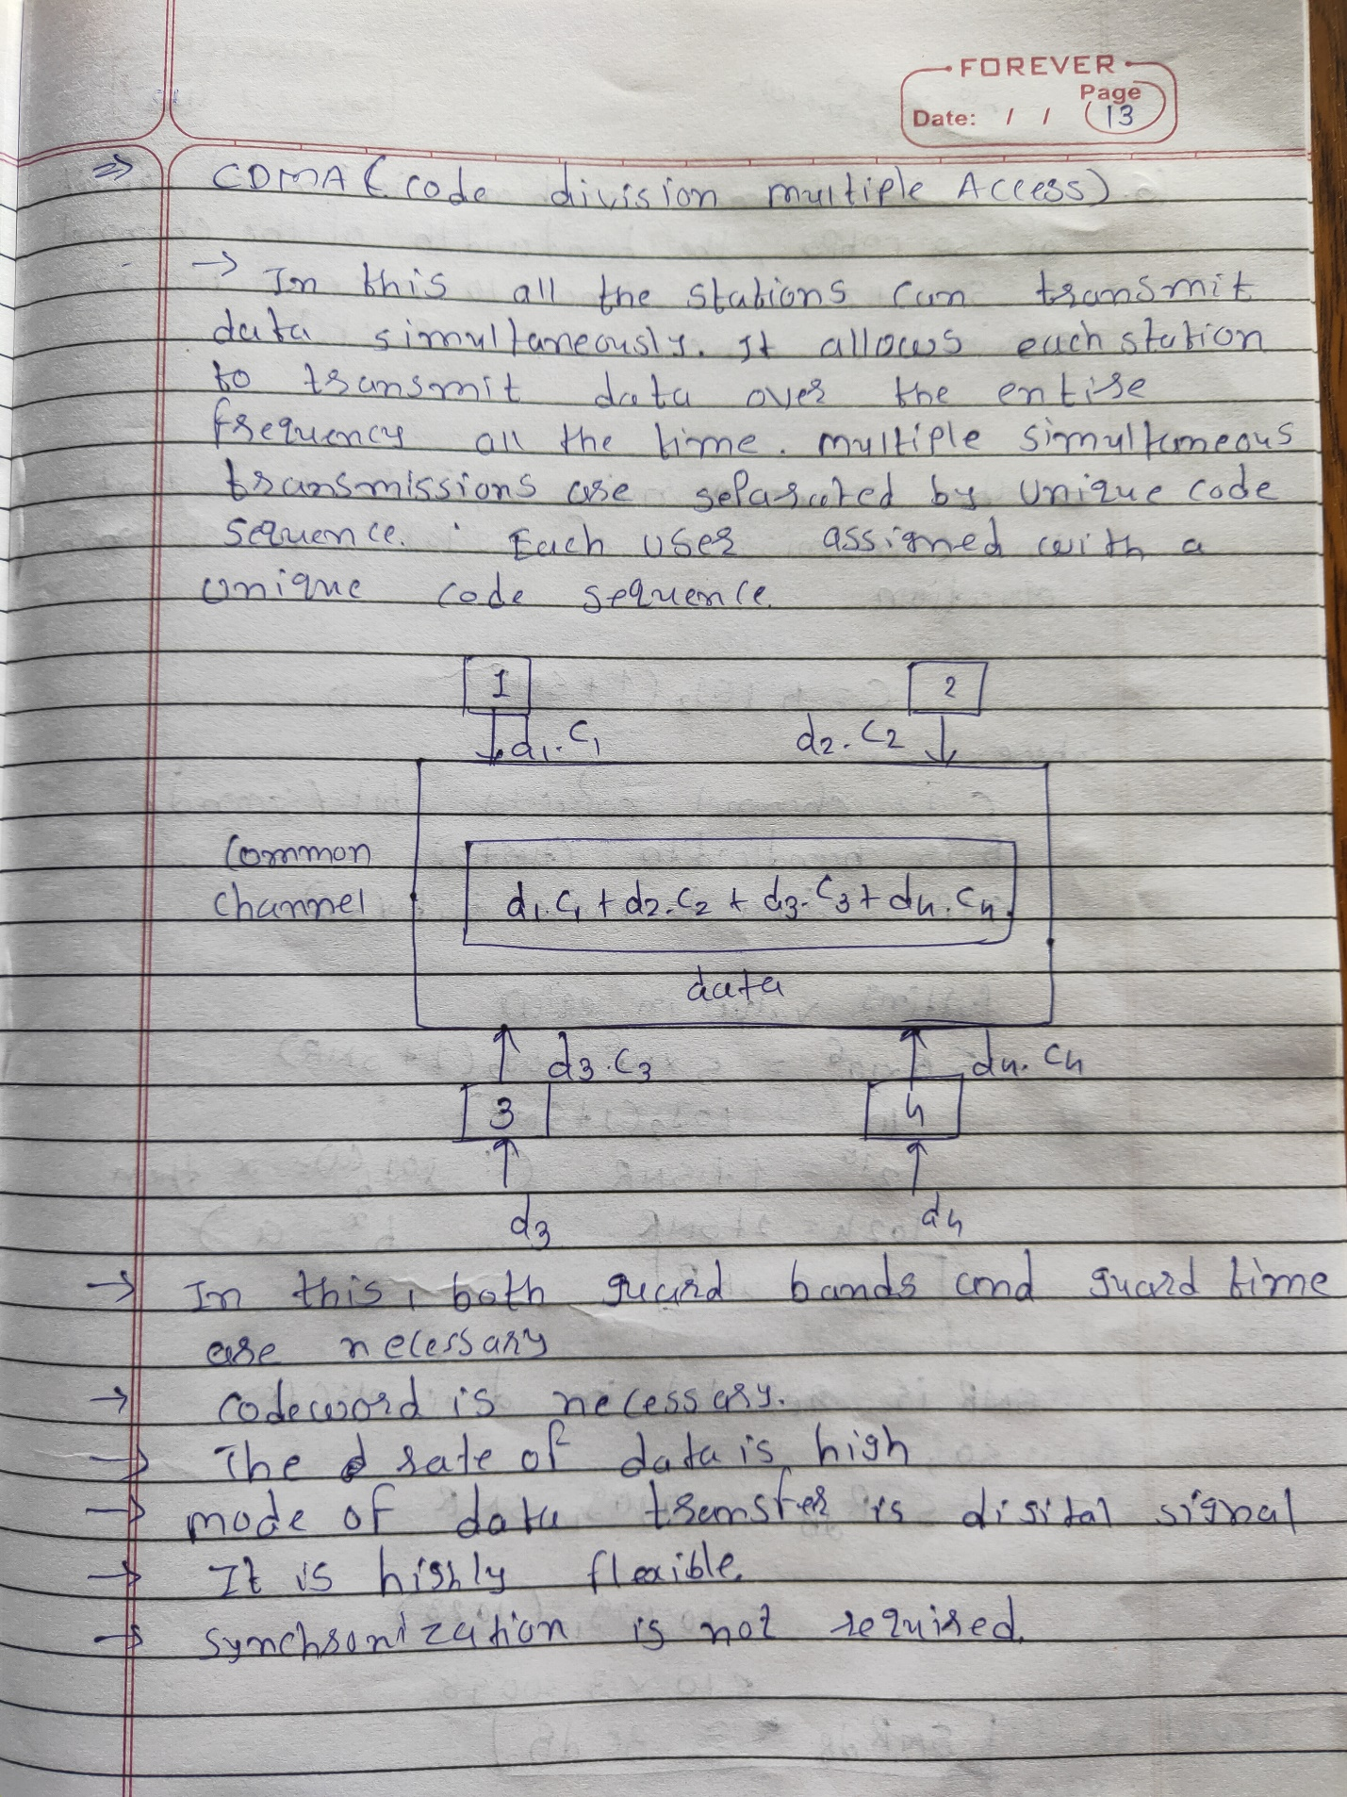

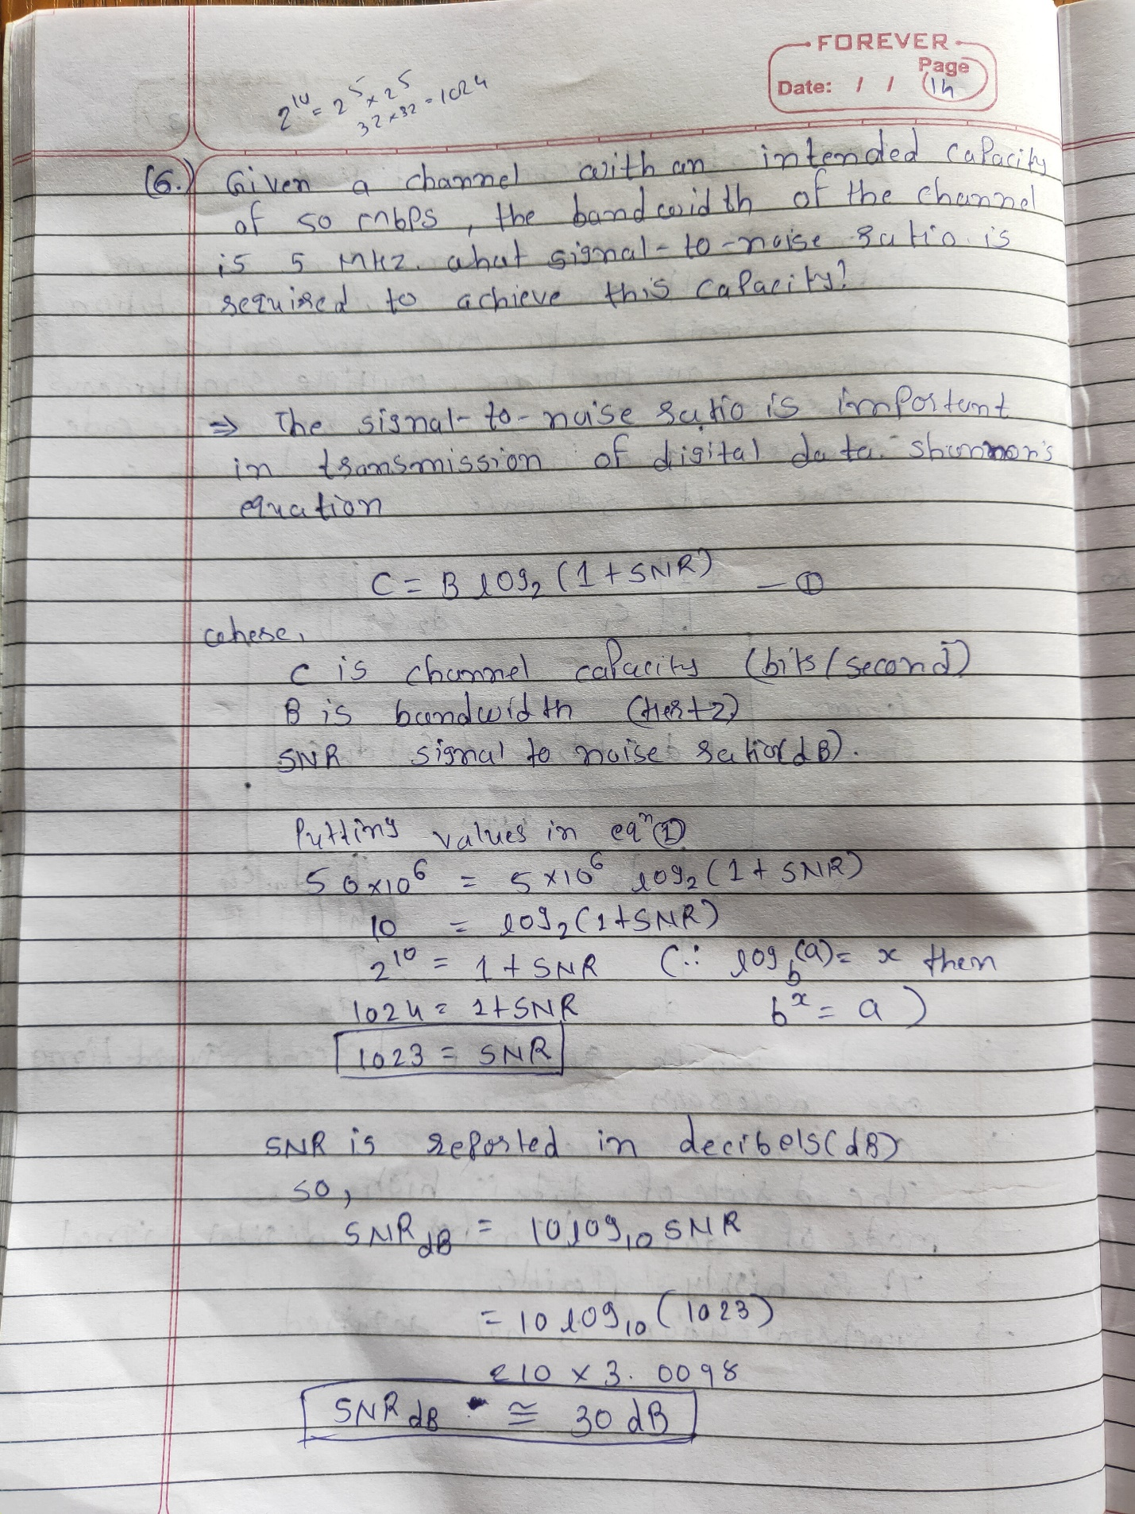

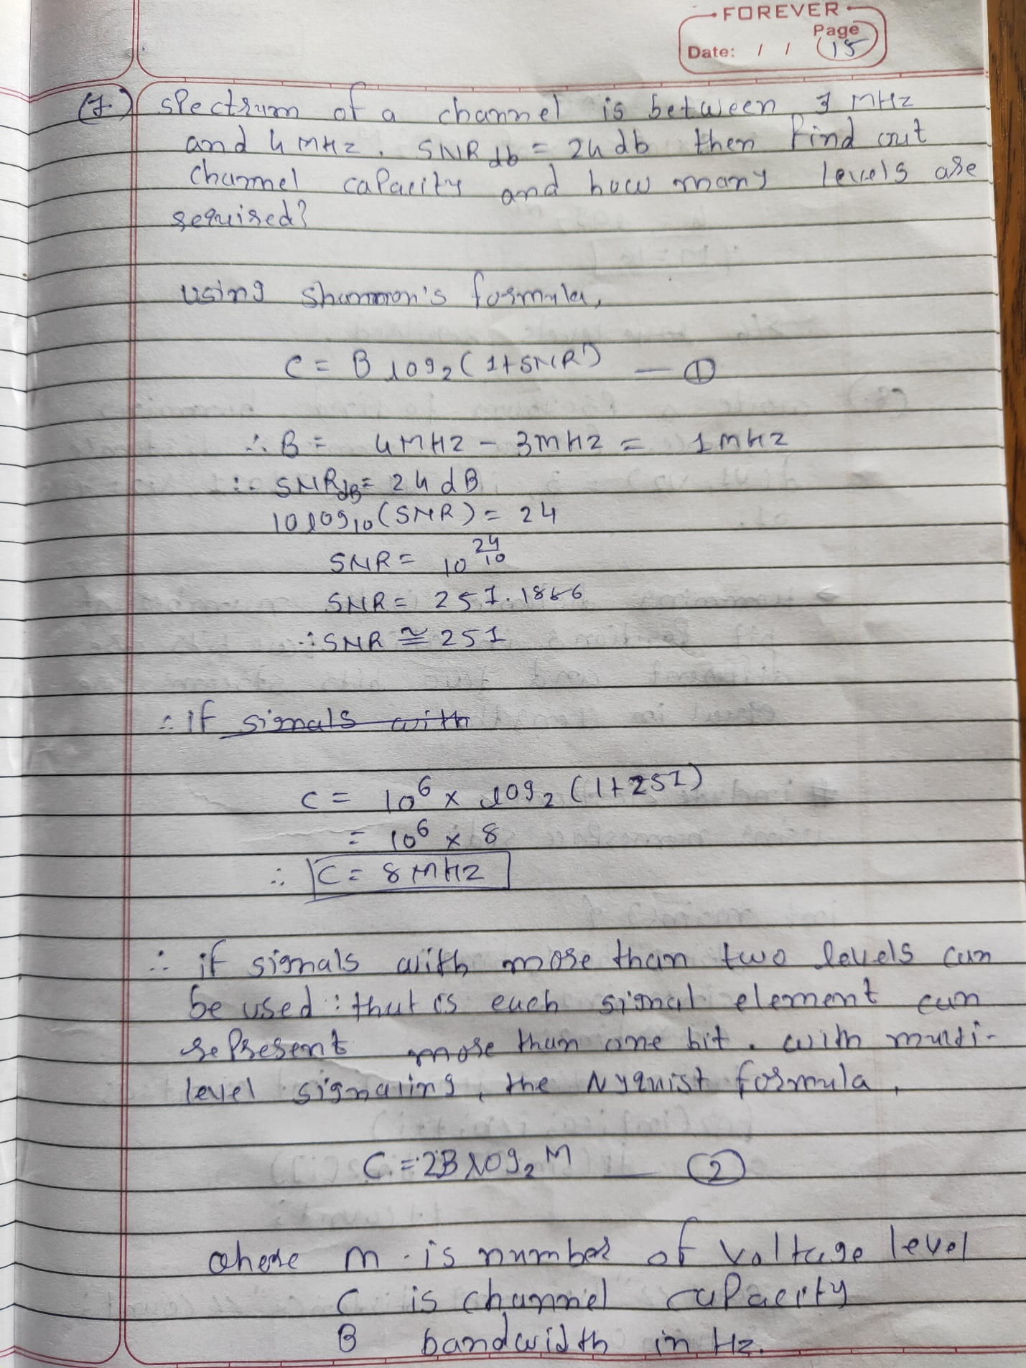

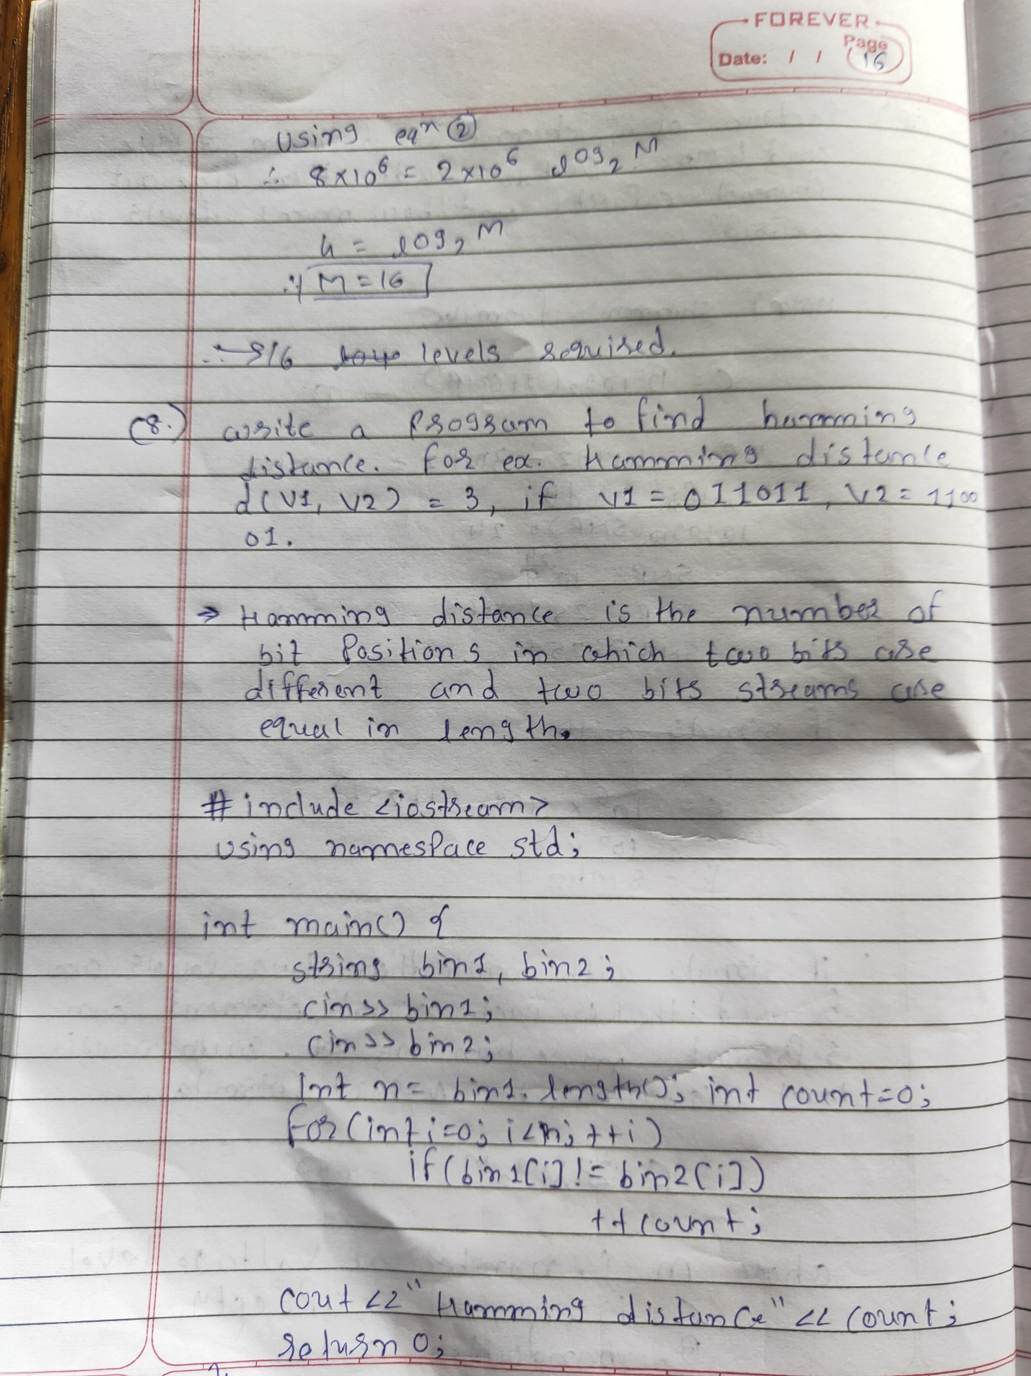

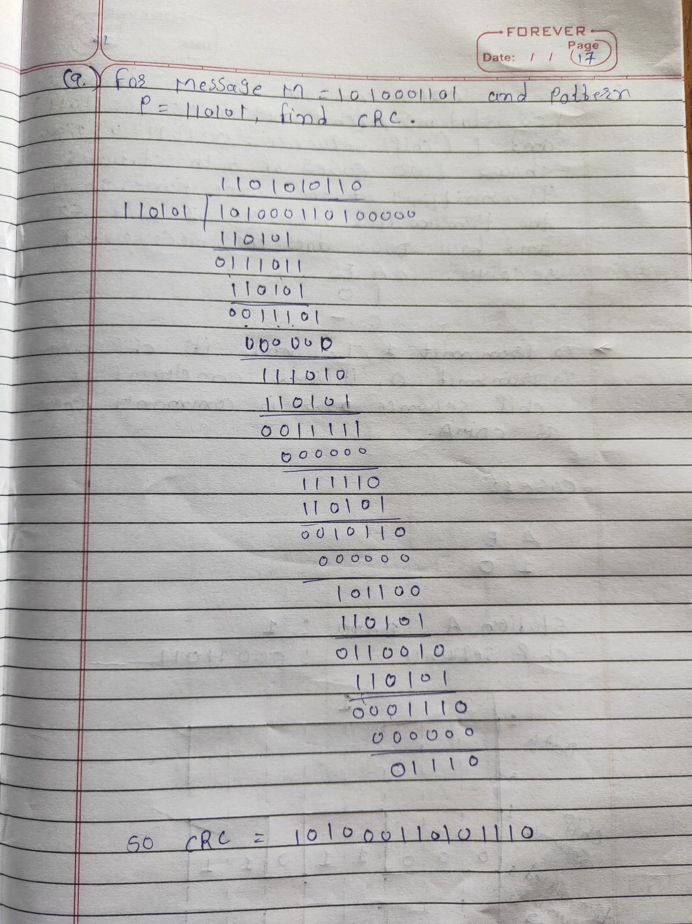

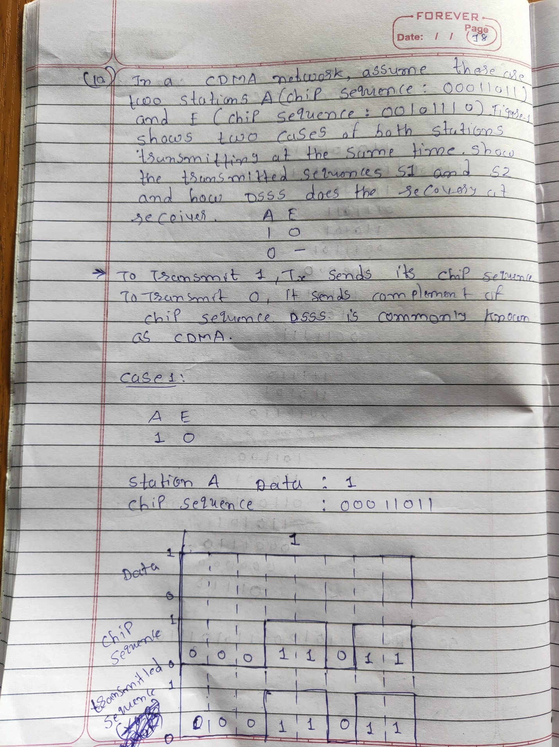

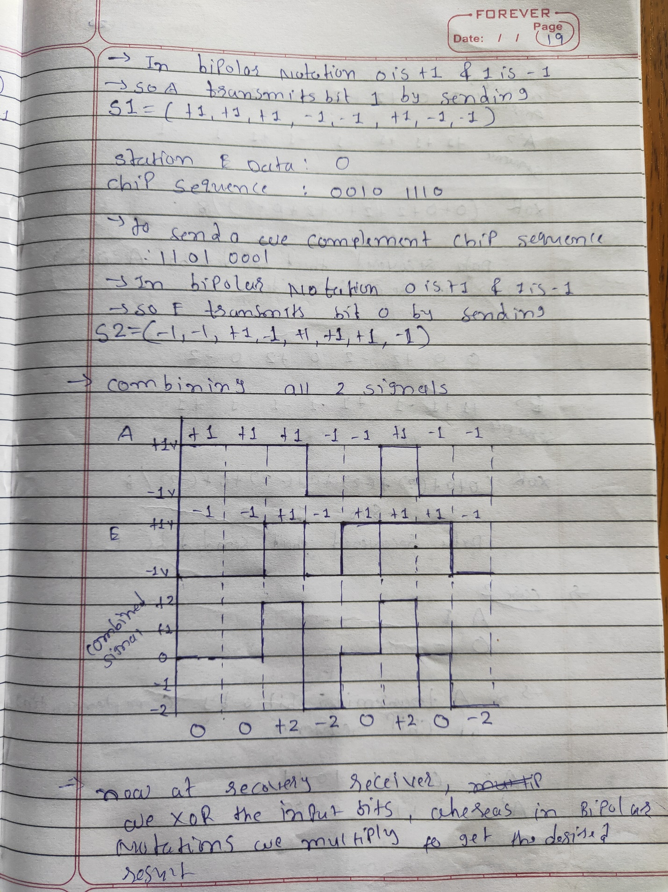

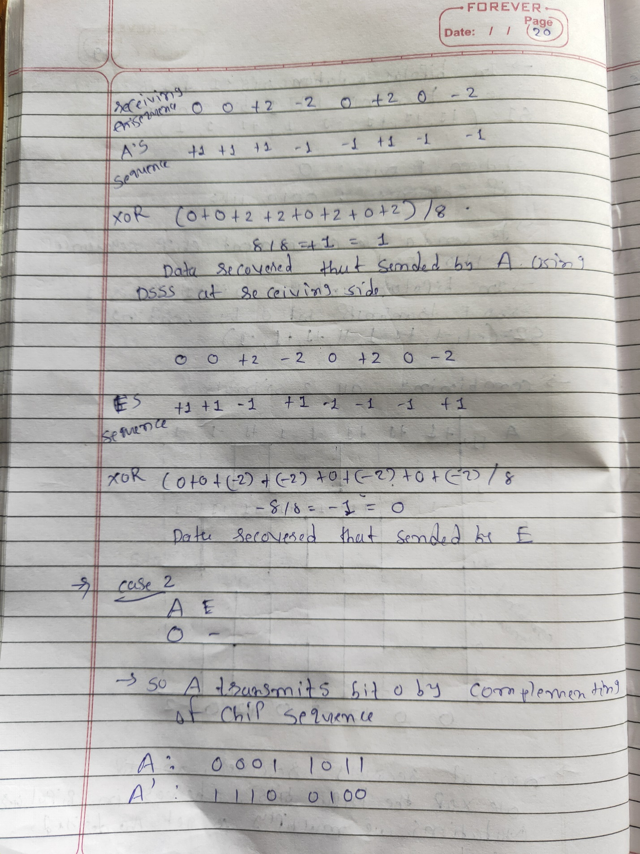

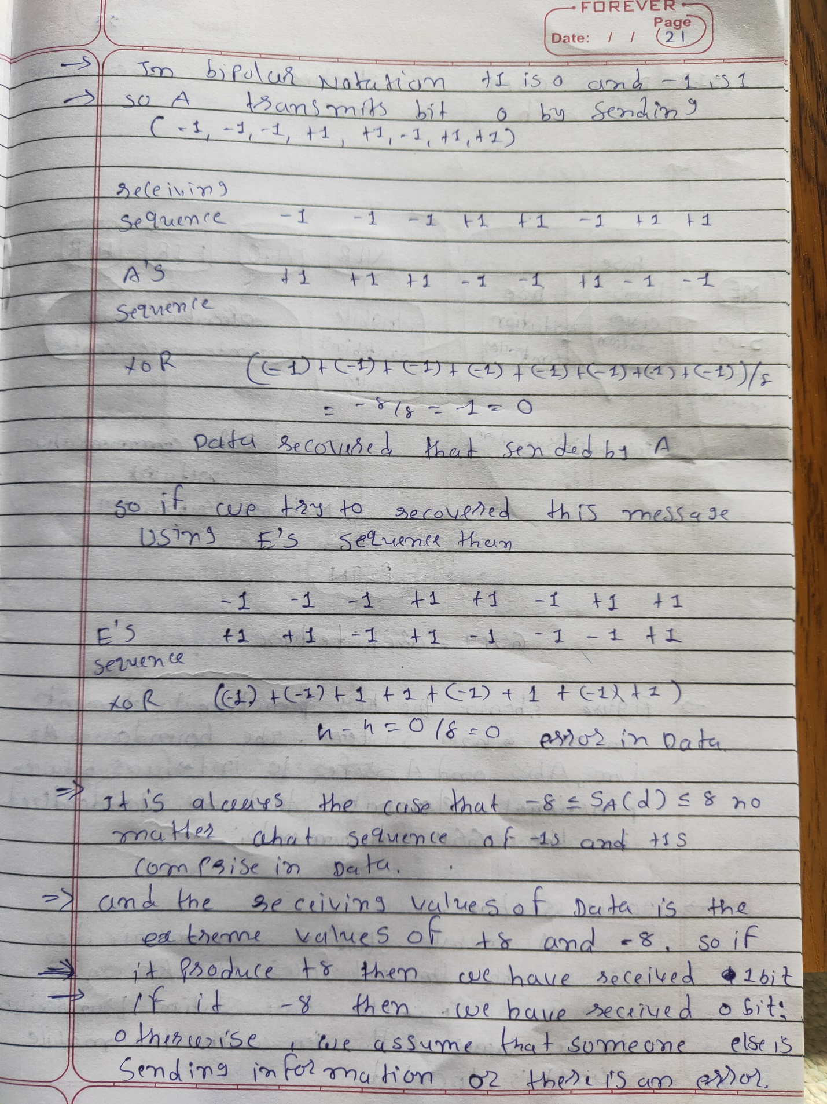

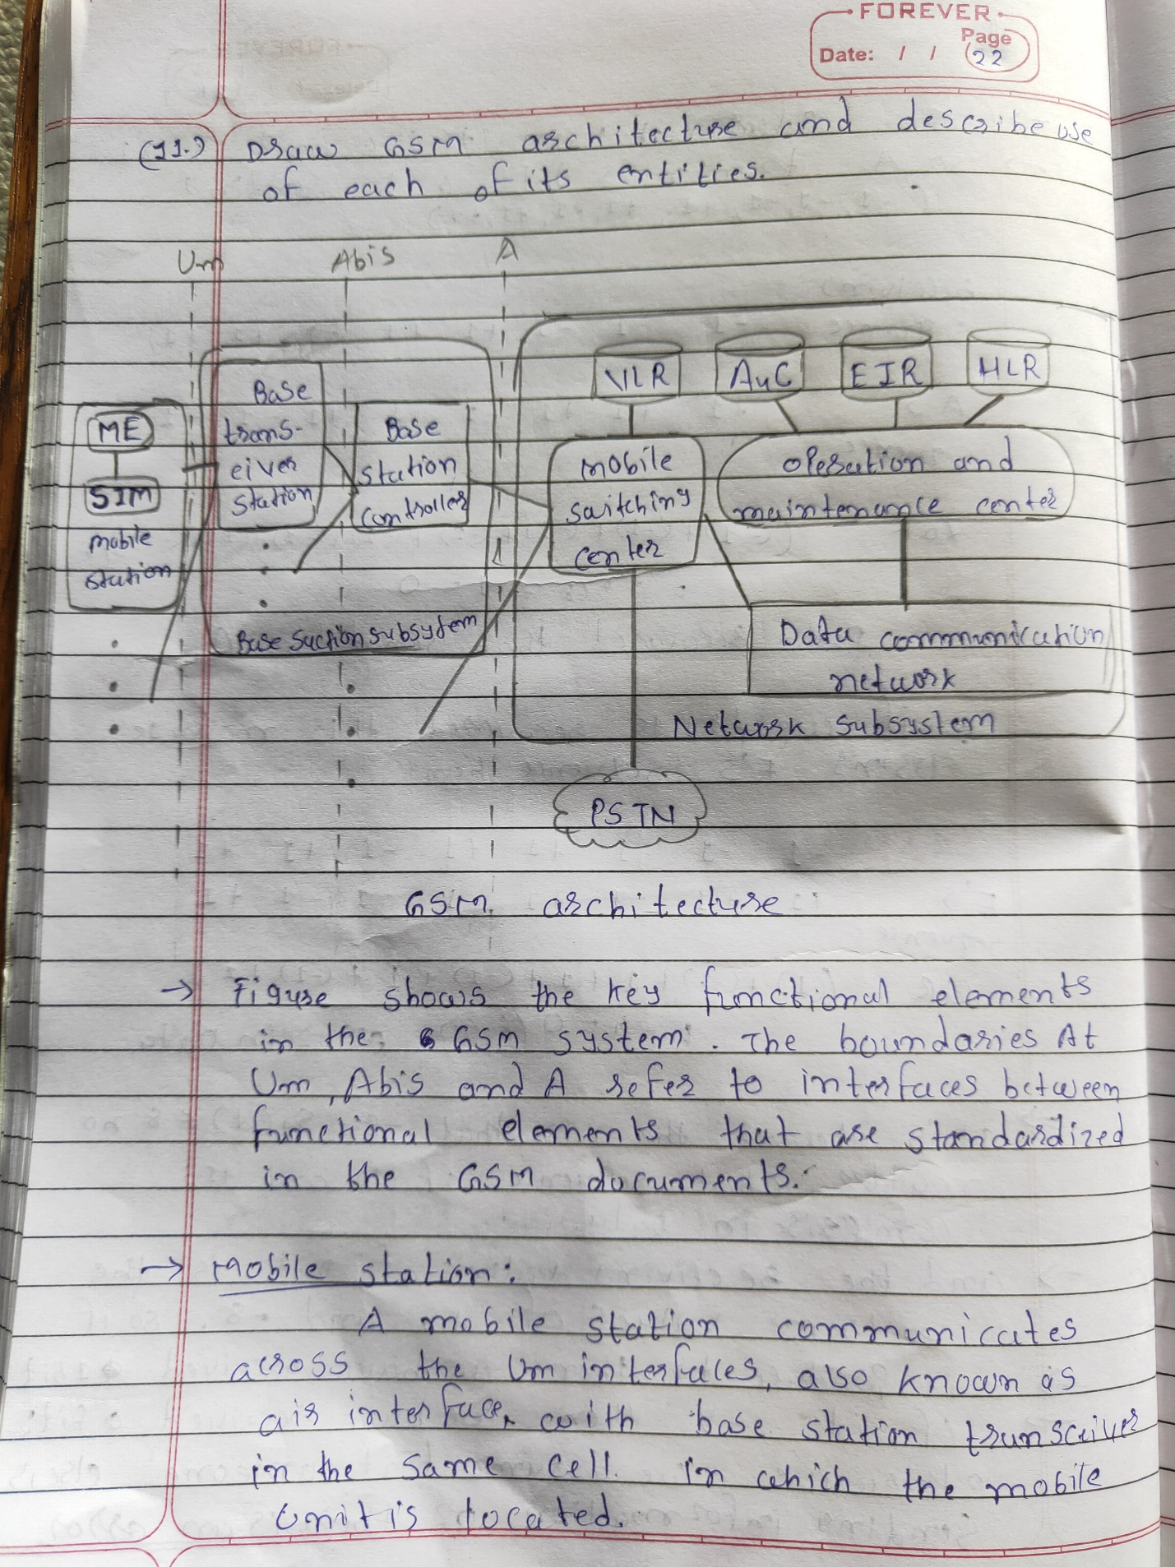

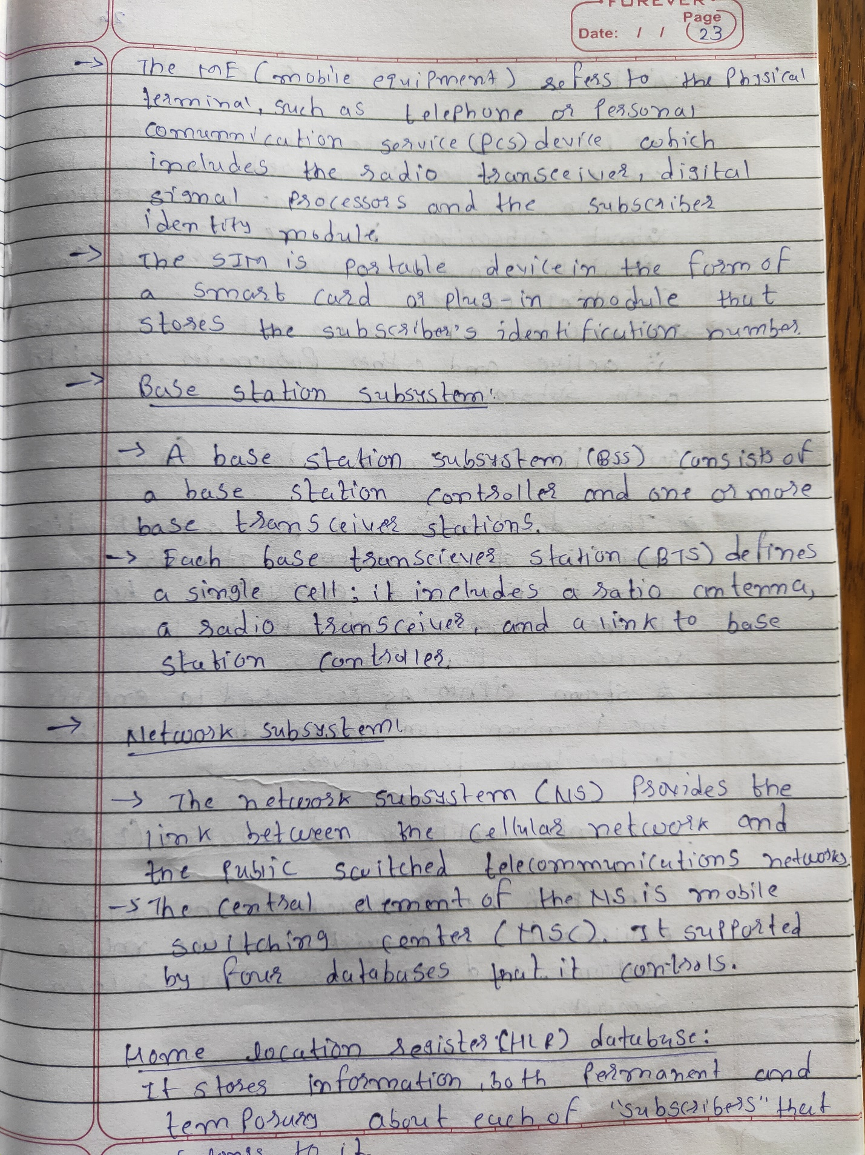

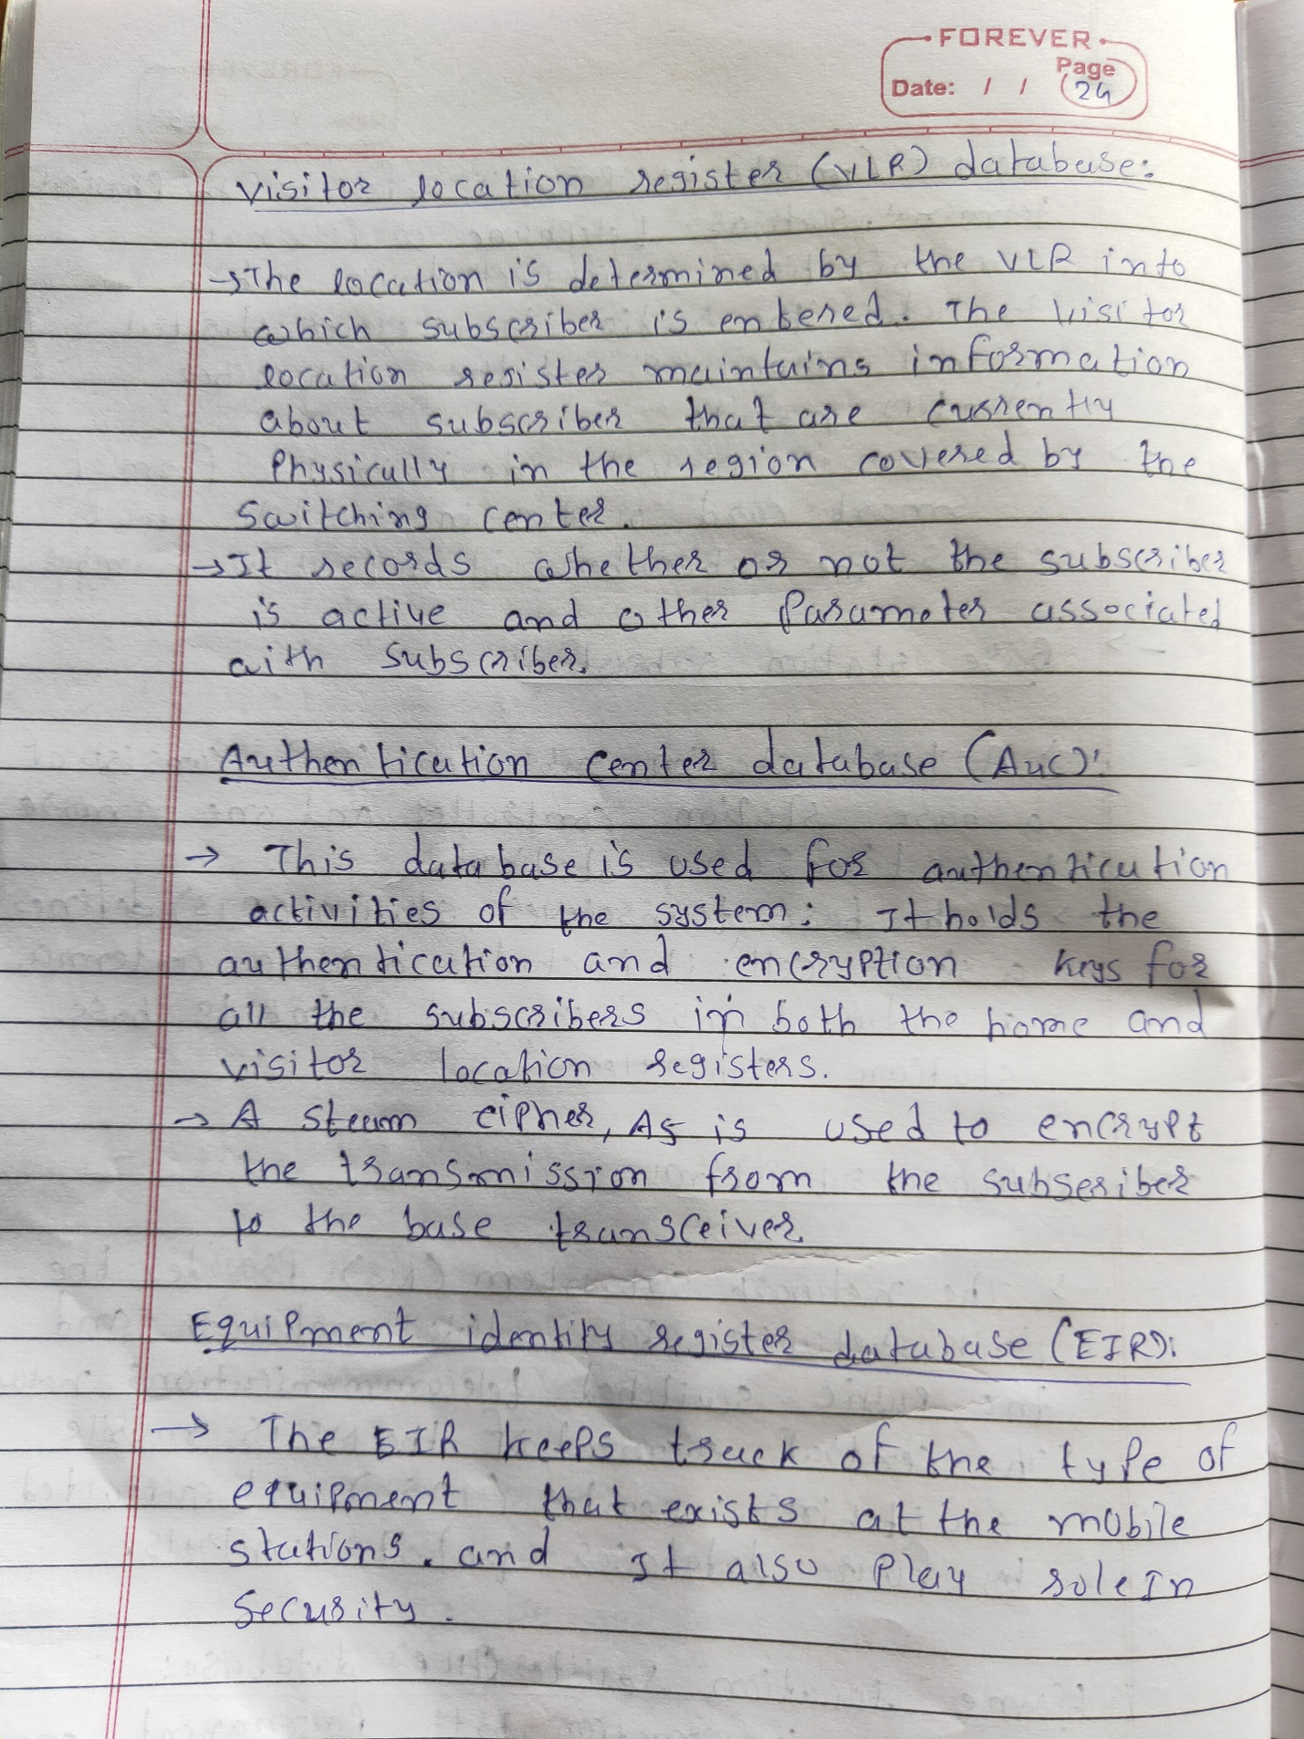

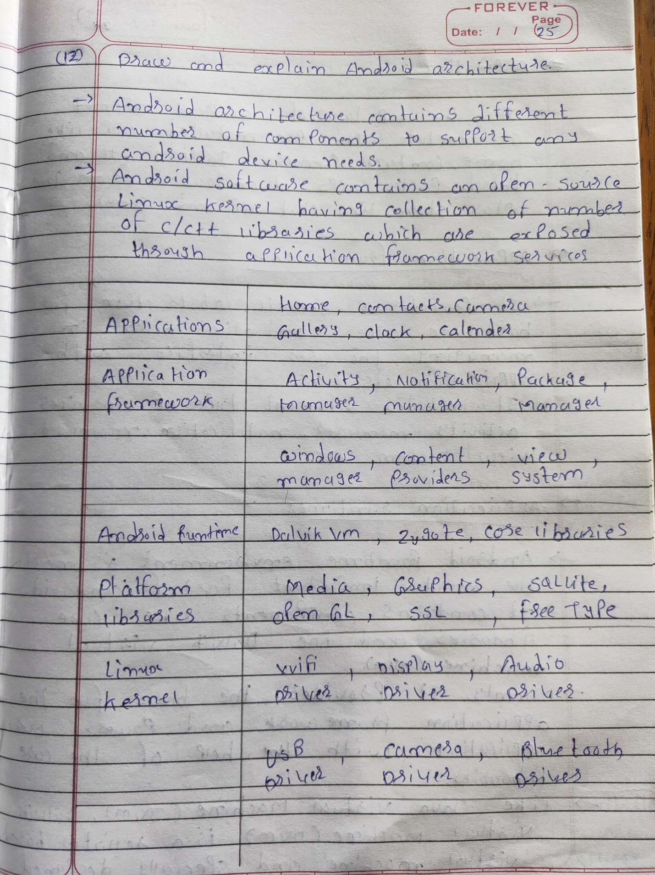

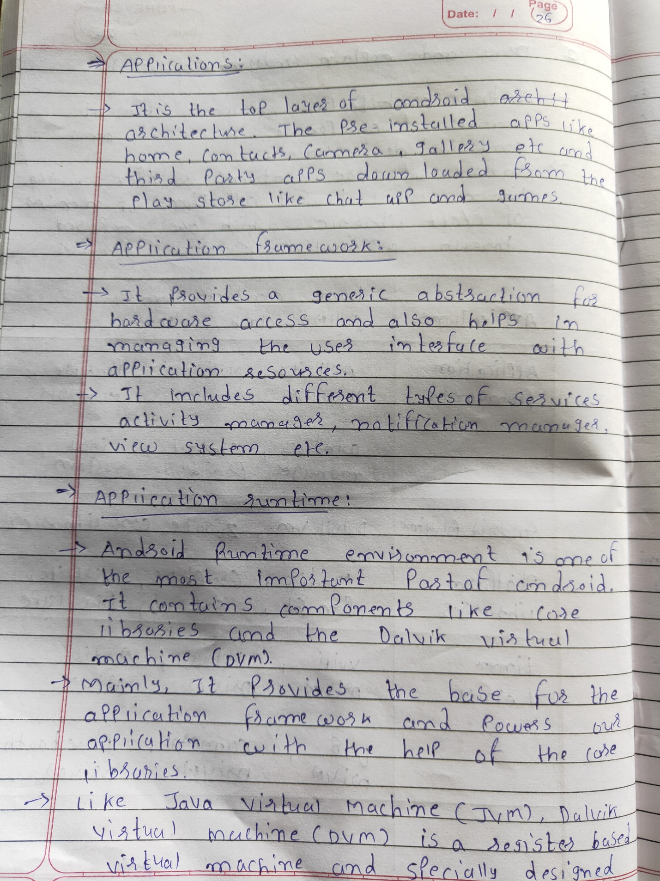

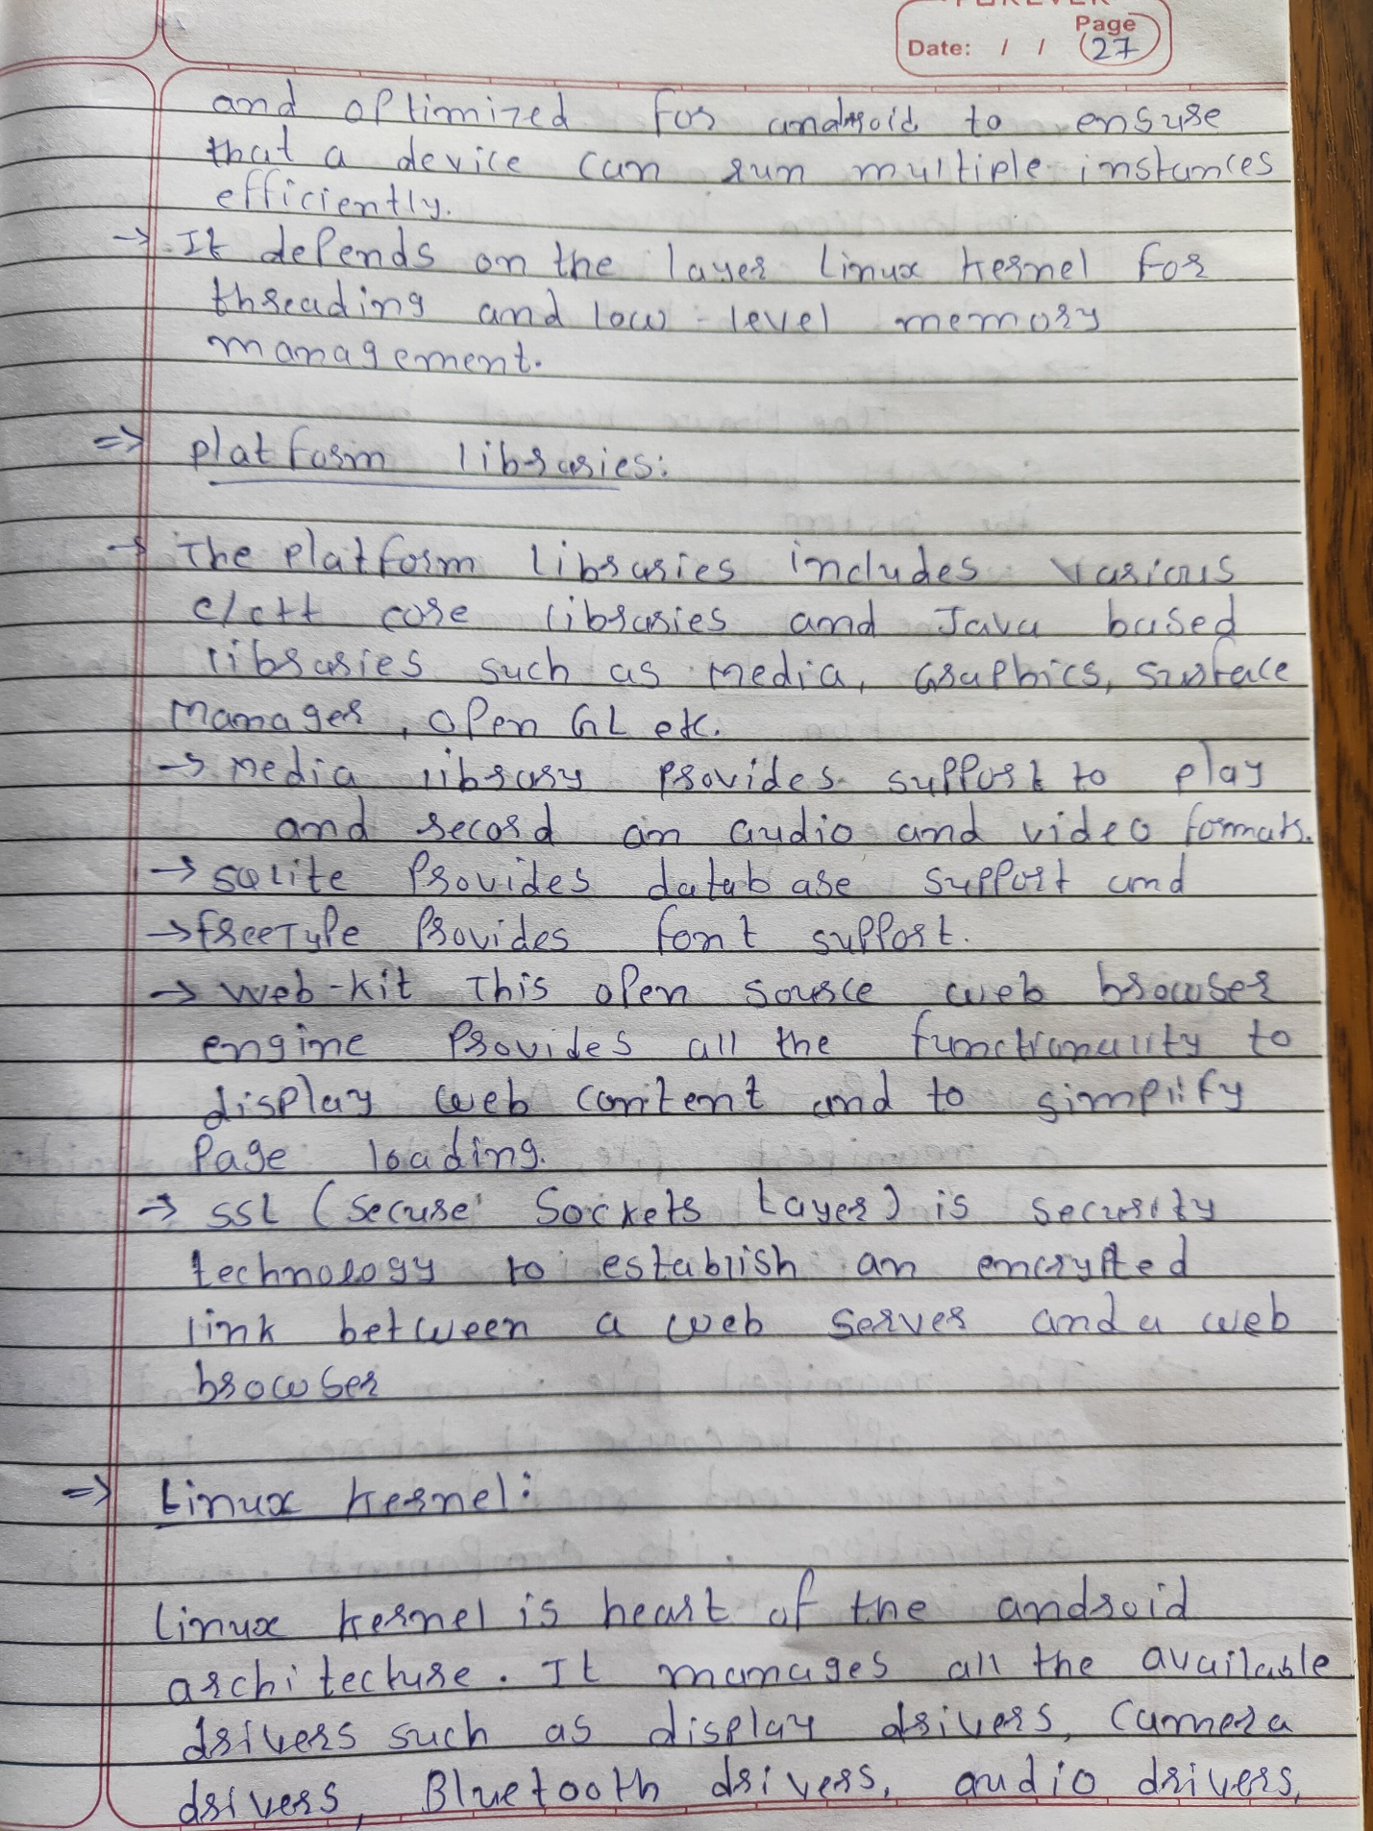

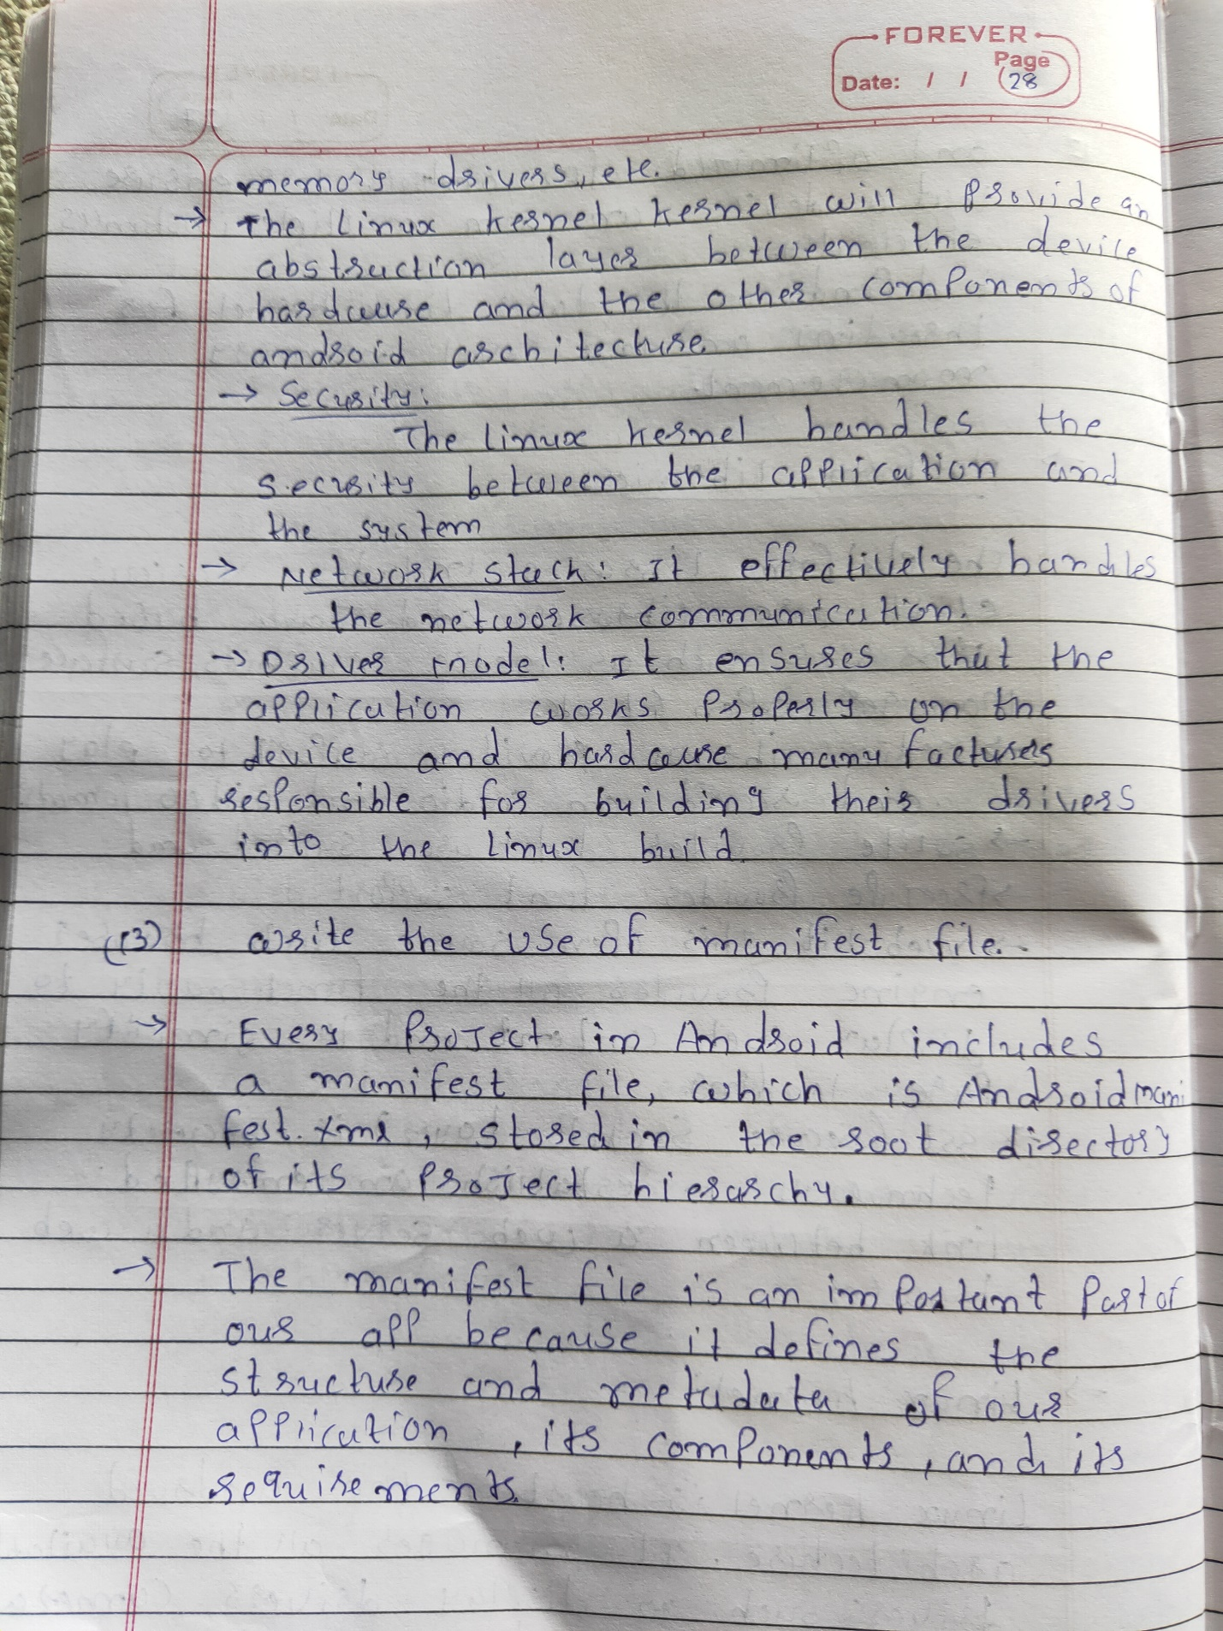

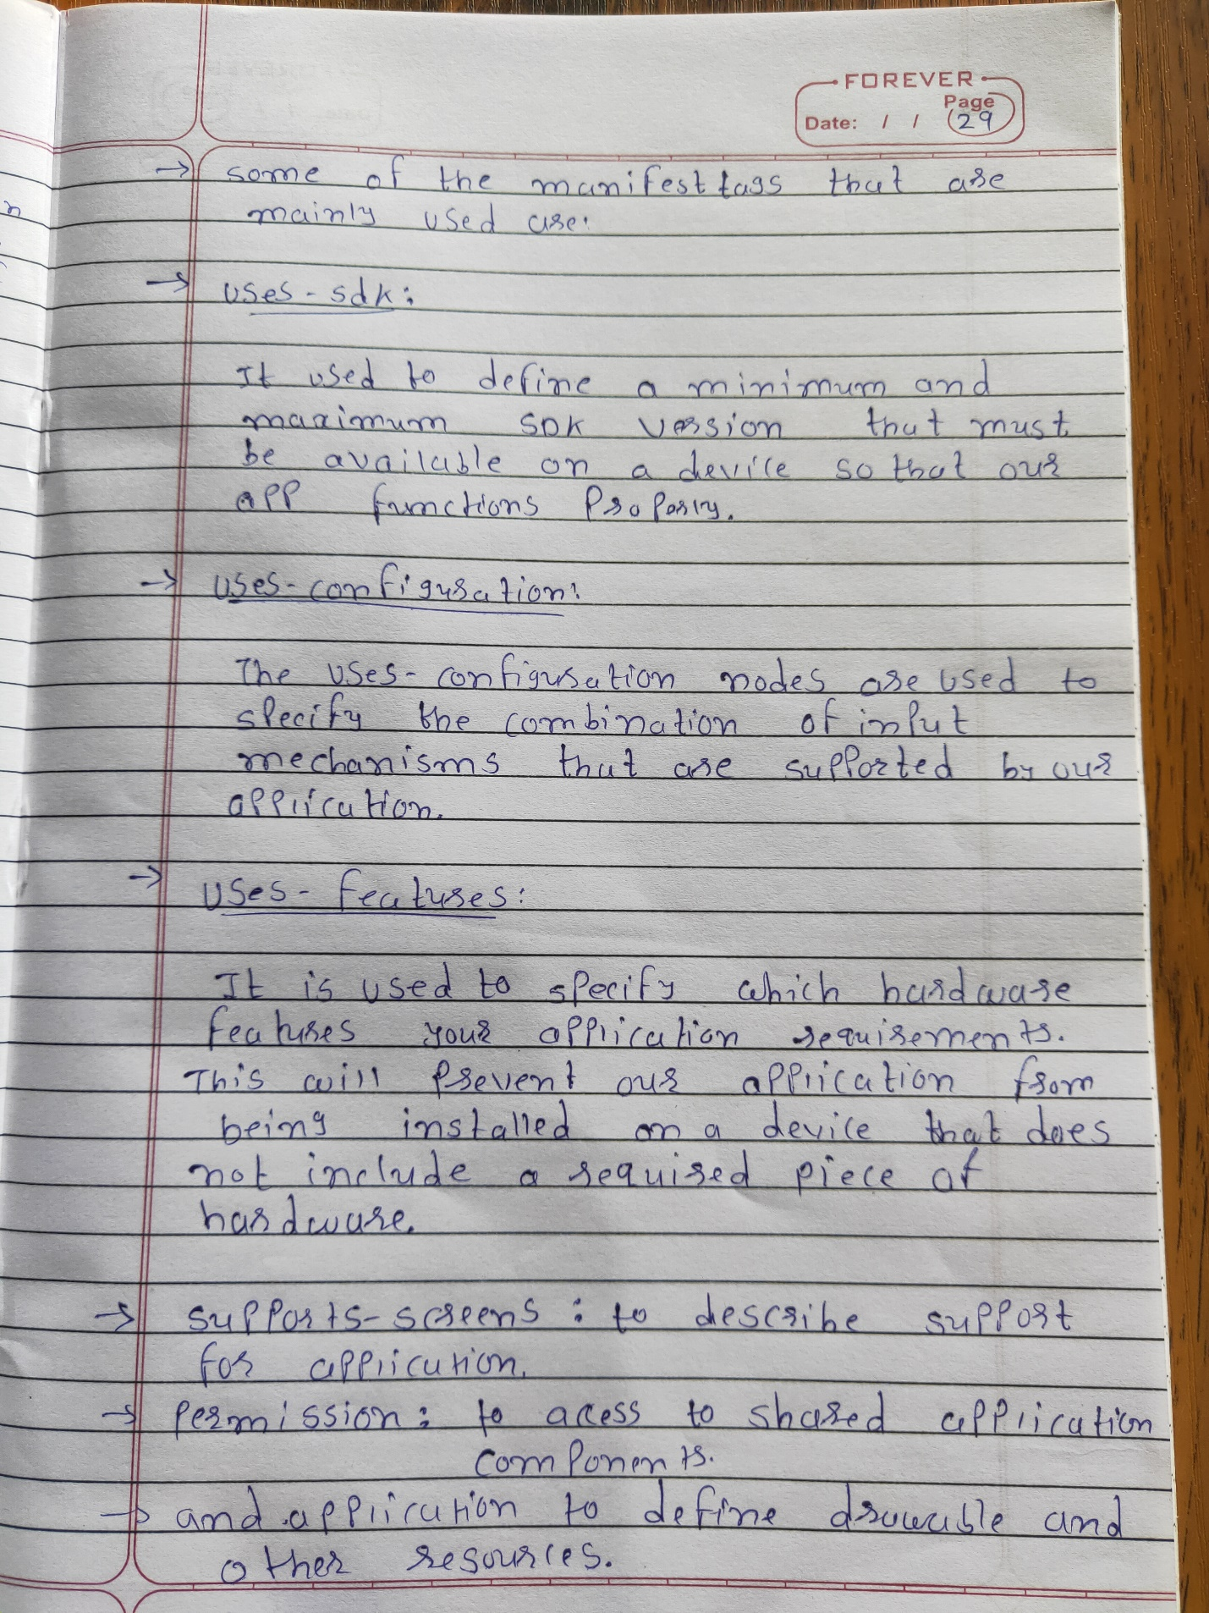

**CRC Program:**

//============================================================================

// Name : CRCparity.cpp

// Author : SidPro

// Version : 1.0

// Description :

/*

=> cyclic redundancy check (CRC), which is used in networks such as LANs and WANs.

=> cyclic codes have a very good performance in detecting single-bit

errors, double errors, an odd number of errors, and burst errors. They can easily be

implemented in hardware and software. They are especially fast when implemented in

hardware. This has made cyclic codes a good candidate for many networks.

=> https://en.wikipedia.org/wiki/Cyclic_redundancy_check

*/

//============================================================================

/* input - output format

*

* Enter Data to generate CRC: 110100101

Enter Key: 1101

CRC code: 110100101110

0 0 0

*/

#include <iostream>

#include <string>

#include <tuple>

**using** **namespace** std**;**

tuple**<**string**,**string**>** sender**(**string**,**string**);**

void receiver**(**string**,**string**);**

int main**()** **{**

string keys**,**data**;**

cout**<<**"Enter Data to generate CRC: "**;**

cin**>>**data**;**

cout**<<**"Enter Key: "**;**

cin**>>**keys**;**

tie**(**data**,**keys**)** **=** sender**(**data**,**keys**);**

receiver**(**data**,**keys**);**

**return** 0**;**

**}**

tuple**<**string**,**string**>** sender**(**string data**,**string keys**){**

int lOfKey **=** keys**.**length**(),**i**,**j**;**

int lOfData **=** data**.**length**();**

int range **=** lOfData**+**lOfKey**-**1**;**

char operation**[**range**],**temp**[**lOfKey**];**

data**.**copy**(**operation**,**lOfData**,**0**);**

**for(**i**=**lOfData**;**i**<**range**+**1**;++**i**)**operation**[**i**]** **=** '0'**;**

// for(i=0;i<range;++i)cout<<operation[i];

**for(**j**=**0**;**j**<**lOfKey**;++**j**){**

temp**[**j**]** **=** operation**[**j**];**

**}**

**for(**i**=**0**;**i**<**lOfData**;++**i**){**

**if(**temp**[**0**]==**'1'**){**

**for(**j**=**0**;**j**<**lOfKey**;++**j**){**

**if((**temp**[**j**]==**'0'**&&**keys**[**j**]==**'0'**)||(**temp**[**j**]==**'1'**&&**keys**[**j**]==**'1'**)){**

temp**[**j**]** **=** '0'**;**

**}**

**else**

temp**[**j**]** **=** '1'**;**

**}**

**for(**j**=**0**;**j**<**lOfKey**-**1**;++**j**){**

temp**[**j**]** **=** temp**[**j**+**1**];**

**}**

temp**[**j**]** **=** operation**[**i**+**lOfKey**];**

**}**

**else{**

**for(**j**=**0**;**j**<**lOfKey**;++**j**){**

**if(**temp**[**j**]==**'1'**){**

temp**[**j**]** **=** '1'**;**

**}**

**else**

temp**[**j**]** **=** '0'**;**

**}**

**for(**j**=**0**;**j**<**lOfKey**-**1**;++**j**){**

temp**[**j**]** **=** temp**[**j**+**1**];**

**}**

temp**[**j**]** **=** operation**[**i**+**lOfKey**];**

**}**

// cout<<"\n"<<i<<" ";

// for(j=0;j<lOfKey;++j)cout<<temp[j];

**}**

**for(**j**=**0**;**j**<**lOfKey**-**1**;++**j**){**

data **=** data**+**temp**[**j**];**

**}**

cout**<<**"\n"**<<**"CRC code: "**<<**data**;**

**return** make_tuple**(**data**,**keys**);**

**}**

void receiver**(**string data**,**string keys**){**

int lOfKey **=** keys**.**length**(),**i**,**j**;**

int lOfData **=** data**.**length**();**

char operation**[**lOfData**],**temp**[**lOfKey**];**

data**.**copy**(**operation**,**lOfData**,**0**);**

// for(i=0;i<lOfData;++i)cout<<operation[i];

**for(**j**=**0**;**j**<**lOfKey**;++**j**){**

temp**[**j**]** **=** operation**[**j**];**

**}**

**for(**i**=**0**;**i**<**lOfData**-**lOfKey**+**1**;++**i**){**

**if(**temp**[**0**]==**'1'**){**

**for(**j**=**0**;**j**<**lOfKey**;++**j**){**

**if((**temp**[**j**]==**'0'**&&**keys**[**j**]==**'0'**)||(**temp**[**j**]==**'1'**&&**keys**[**j**]==**'1'**)){**

temp**[**j**]** **=** '0'**;**

**}**

**else**

temp**[**j**]** **=** '1'**;**

**}**

**for(**j**=**0**;**j**<**lOfKey**-**1**;++**j**){**

temp**[**j**]** **=** temp**[**j**+**1**];**

**}**

temp**[**j**]** **=** operation**[**i**+**lOfKey**];**

**}**

**else{**

**for(**j**=**0**;**j**<**lOfKey**;++**j**){**

**if(**temp**[**j**]==**'1'**){**

temp**[**j**]** **=** '1'**;**

**}**

**else**

temp**[**j**]** **=** '0'**;**

**}**

**for(**j**=**0**;**j**<**lOfKey**-**1**;++**j**){**

temp**[**j**]** **=** temp**[**j**+**1**];**

**}**

temp**[**j**]** **=** operation**[**i**+**lOfKey**];**

**}**

// cout<<"\n"<<i<<" ";

// for(j=0;j<lOfKey;++j)cout<<temp[j];

**}**

cout**<<**"\n"**;**

**for(**j**=**0**;**j**<**lOfKey**-**1**;++**j**){**

cout**<<**" "**<<**temp**[**j**];**

**}**

**}**

**Hamming Distance:**

// 'Ctrl +' to increase font size

// 'Ctrl -' to decrease font size

// 'Ctrl 0' to Reset Font size

// 'Ctrl q' for more help

// Sample code to perform I/O:

#include <iostream>

**using** **namespace** std**;**

int main**()** **{**

string bin1**,**bin2**;**

cin**>>**bin1**;**

cin**>>**bin2**;**

int n **=** bin1**.**length**();**

int hamming_distance**=**0**;**

**for(**int i**=**0**;**i**<**n**;++**i**)**

**if(**bin1**[**i**]!=**bin2**[**i**])**

**++**hamming_distance**;**

cout**<<**"hamming_distance:"**<<**hamming_distance**;**

**return** 0**;**

**}**

// Write your code here